Unit 1: Module 4, Workbook

Navigation pane and page breaks
The guidance in this document is for Word 2010. The menu set up and keystrokes may be different in other versions of Word.
What is the navigation pane? 2
Open the navigation pane 3
Checking styles 4
Open Draft view 4
What are page breaks? 5
Inserting a page break 5
Time to practise! 6
Exercise 1 6
Answers to exercises 7
Exercise 1 7

What is the navigation pane?
The navigation pane allows you to view and easily go to the different sections in your document, without having to scroll.
The navigation pane will sit in a window on the left-hand side of your editing window. It displays all of the text you have styled as a Heading – for example all the chapter titles styled as Heading 1.
From the navigation pane you can quickly check that the structure of your document makes sense and ensure there are no blank lines with Heading styles assigned to them.
The section of the document you’re reading will be highlighted in the navigation pane.
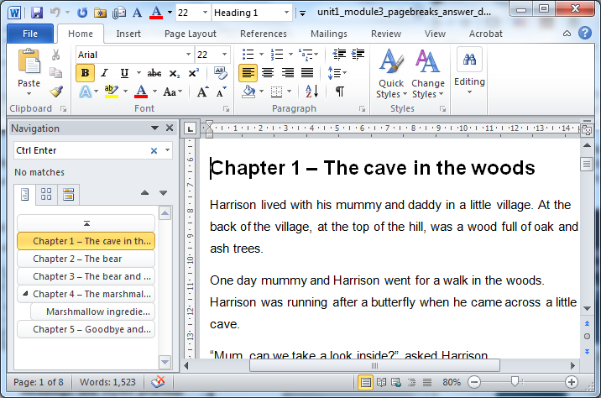
You can select any heading in the navigation pain and you’ll be taken straight to that heading within the document.
Note: Word 2003 and 2007 call this the Document map.
The navigation pane has three tabs to give you different views of the document:
- Styled headings
- By page
- Search results (if you search for a word or phrase in the top box of the pane)

Open the navigation pane
Method | Action
Shortcut keys | Ctrl F
By mouse | - Select the View ribbon  - Go to the Show section  - Check the Navigation pane box
By keyboard (via the menu) | - Alt W to get the the View ribbon  - K to check the Navigation pane box

Checking styles
It’s possible to view all the text styles and page breaks that have been applied, not just Headings, by reading your document in Draft view.
This is particularly useful to check that Normal is still applied to all blank lines rather than risk causing potential confusion to someone reading the document with a screen reader.

Open Draft view
Method | Action
Shortcut keys | Alt W N  Alt W P (to return to Print Layout)
By mouse | - Select the View ribbon  - Go to Document views  - Select Draft
By keyboard (via the menus) | Alt W and then E  Alt W and then P (to return to Print Layout)

If styles are not visible in the left-hand margin then:
- go to the File ribbon and choose Options
- select Advanced
- scroll down to the Display section
- Go to Style area pane width and set to two centimetres.

What are page breaks?
A page break or hard page break tells the programme to end the current page and begin the next. After the page break is inserted into the document the cursor is placed on the next page.
We insert page breaks at the end of section, so that the next piece of text styled as a Heading 1, is on the start of a new page. For example, starting each chapter on a new page.
Inserting the page break and having your Heading 1 on a new page, allows the documents structure to be fully recognised by content convertors, reading apps and access technology such as screen readers. It also means that the reader doesn’t have to scroll through lots of blank lines, providing a more pleasant reading experience.

Inserting a page break
Method | Action
Shortcut keys | Ctrl Enter
By mouse | - Select the Page layout ribbon  - Go to the Page set up section  - View the Breaks drop down menu  - Select Page
By keyboard (via the menus) | - Alt P to get the the Page layout  - B to get to the Breaks drop down menu  - P to insert the page break

Time to practise!

Exercise 1
You can either enter the page breaks as you go through the creation of document, or go back through afterwards and put them in. The former may be preferable, however for this exercise we are going to insert the page breaks into the short chapter book you were working on in Module 3.
Open the Exercise 1: Page breaks – practise document

Insert page breaks
You are only putting in page breaks for the chapter headings styled as Heading 1. The Heading 2 section “Marshmallow ingredients” does not require a page break.
- From the Navigation pane, select Chapter 1.
- Ensure the cursor is at the start of the line “Chapter 1” otherwise the break will split the text. Insert the first page break.
- In the navigation pane select Chapter 2. Enter your second page break.
- Repeat for chapters 3, 4 and 5.
You chapter titles (styled as Heading 1) should now all appear at the top of new pages.

Check the Headings and Styles
- Open the Navigation pane and ensure it’s on the first tab, showing the styled chapter headings.
- In the Navigation pane select the blank Heading under Chapter 3. Remove the blank line and ensure the paragraph “The bear couldn’t …” is styled as Normal.
- Open the Draft view and in Chapter 4, locate the paragraph styled as Caption. Change it to Normal.
- Return the document to Page Layout view.

Answers to exercises

Exercise 1
Download the Exercise 1: Page breaks - answer document to see how your document should look.
The paragraph in Chapter 4 that was incorrectly styled as a Caption was:
“I really hope we can be friends and go on some great adventures together,” said Ziggy Bear. “Do you like marshmallows?” he asked.

---
Author: RNB Bookshare
Date created: 23 December 2016
Date last modified: 16 May 2017, Version 2
File: M:\RNIB Bookshare\Guidance and training for customers\Self-study units\Unit1_Module4_Workbook.docx

