Unit 1: Module 3, Activity 2

Set up your Quick Access Toolbar
Word 2010 2
Word 2007 5
Word 2003 8

Word 2010
- Open Word
- In the top left of the screen you will see the Word icon and possible the “save as” disc icon next to it. Alongside will be an icon showing a line with a triangle underneath – this is the “Customise Quick Access Toolbar” icon.
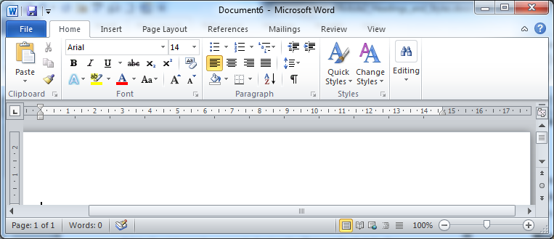
- Select the “Customise QAT” icon
- Select “More commands” from the drop-down menu
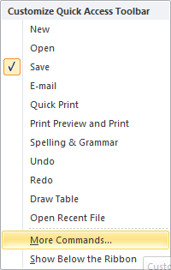
- Select “Style” (not “Styles”) from the list of commands
- Select “Add”
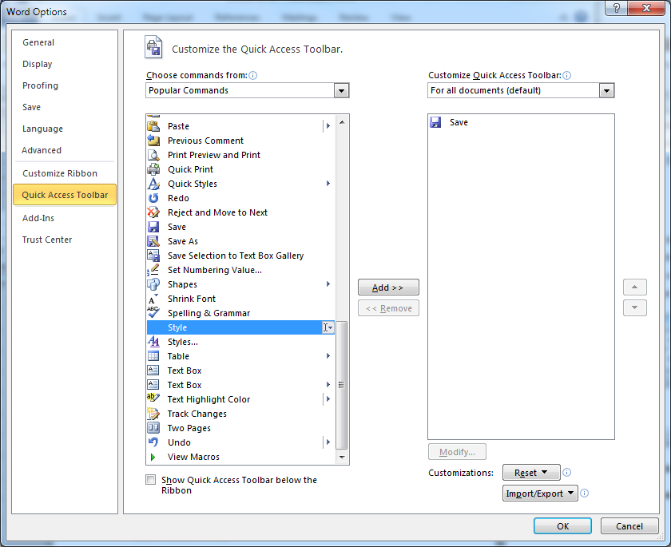
- The “Style” command now appears in the right window
- Select “OK”
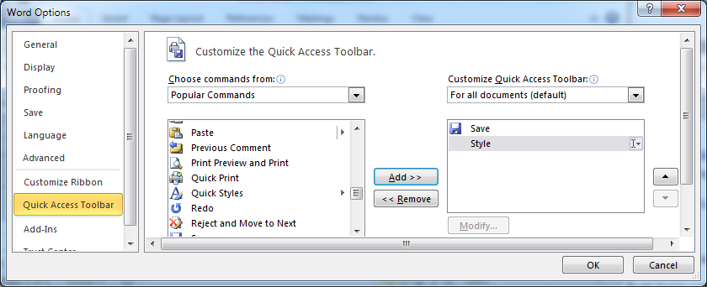
- The “Style” drop-down menu now appears on your QAT.
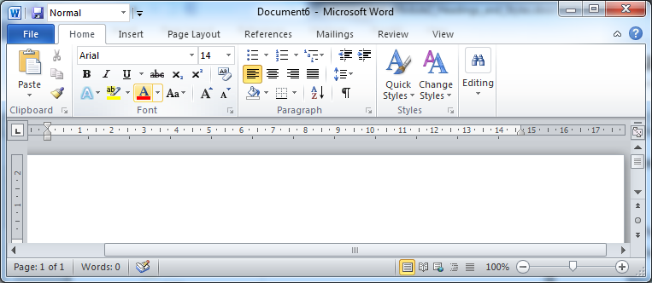
You can select styles from the drop-down menu or place your cursor in the box to highlight the existing style name and start typing the style name you require.

Word 2007
- Open Word
- In the top left of the screen you will see the Word icon and possible the “save as” disc icon next to it. Alongside will be an icon showing a line with a triangle underneath – this is the “Customise Quick Access Toolbar” icon.
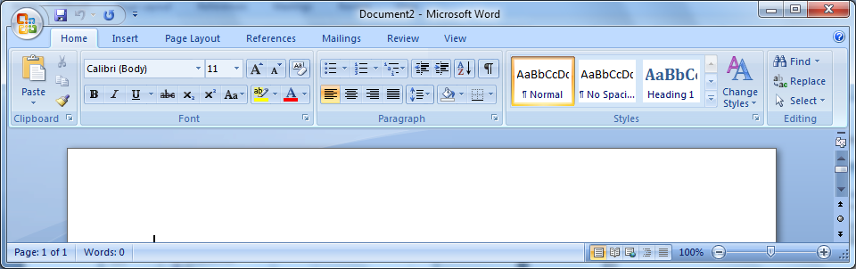
- Select the “Customise QAT” icon
- Select “More commands” from the drop-down menu
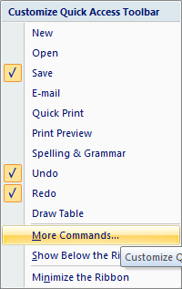

- Select “Style” (not “Styles”) from the list of commands
- Select “Add”
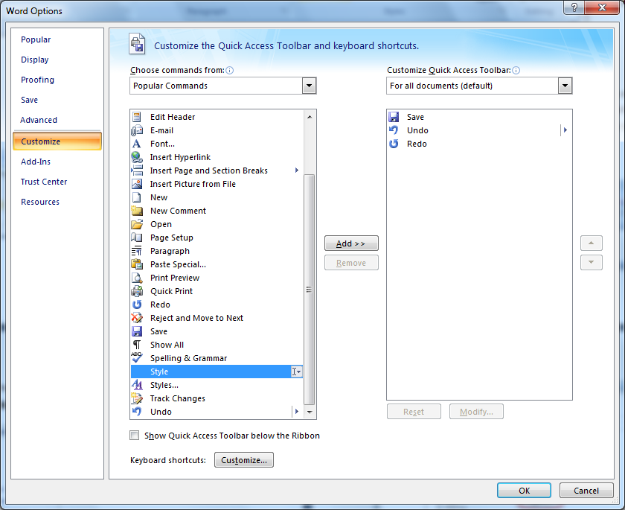
- The “Style” command now appears in the right window
- Select “OK”
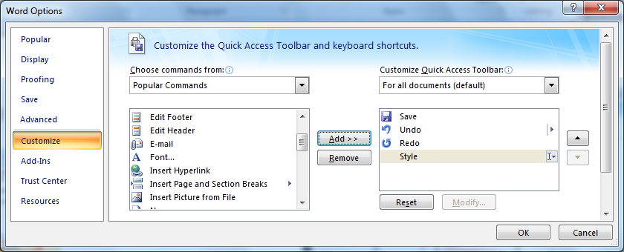
- The “Style” drop-down menu now appears on your QAT.
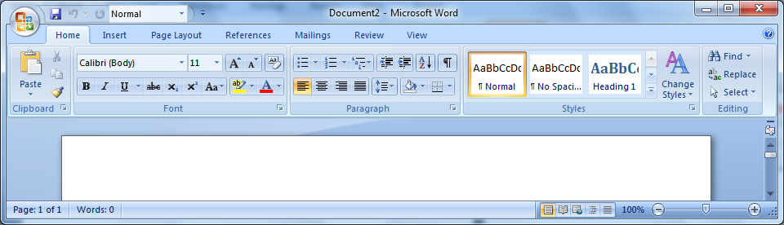
You can select styles from the drop-down menu or place your cursor in the box to highlight the existing style name and start typing the style name you require.

Word 2003
- Open Word
- At the top of the screen you will see “Standard” toolbar, listing the headings for the drop-down menus, such as “File, Edit, View, Insert, Format”.
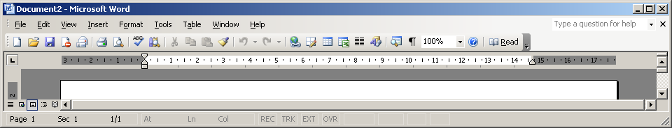
- Right click your mouse anywhere on the “Standard” toolbar
- Select “Formatting” from the drop-down menu
- You will now see the “Formatting” toolbar.
- The “style” box will have the word “Normal” in the window
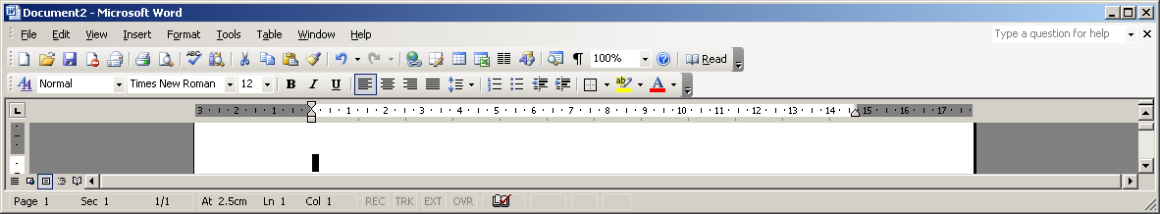
You can select styles from the drop-down menu or place your cursor in the box to highlight the existing style name and start typing the style name you require.

---
Author: RNIB Bookshare
Date created: 23 January 2017
Date last modified: 16 May 2017, Version 2
File: M:\RNIB Bookshare\Guidance and training for customers\Self-study units\Unit1_Module3_Activity2.docx

