RNIB Bookshare: Sending PDF titles to Kindle App on iPad/devices
This allows reflow of text when increasing/decreasing font size.

One off set up procedure to be able to send books to learners
Ensure Kindle App is installed on the learner’s iPad / device. The Member (learner) will need to:
- Find out what their Kindle email address is (see below)
- Add the Sponsors (staff) email address to approved list (see below)

Find out learners Kindle email address
- Sign into your Amazon account
- Select Manage Your Content and Devices
- From Settings tab, scroll down to Personal Document Settings
- Under Send-to-Kindle Email Settings, your Send to Kindle email address will be listed
(Image below shows where ‘Your Account’ can be found on Amazon.com)
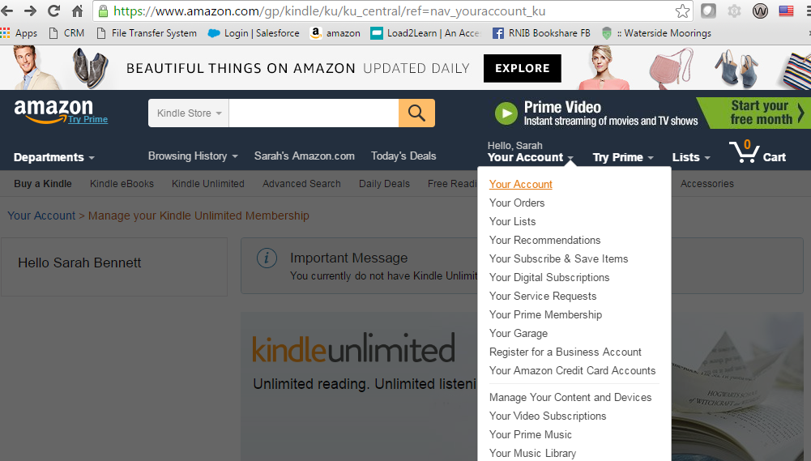

- Select ‘Manage Your Content and Devices’ (image below shows where to find this link under Digital Management)
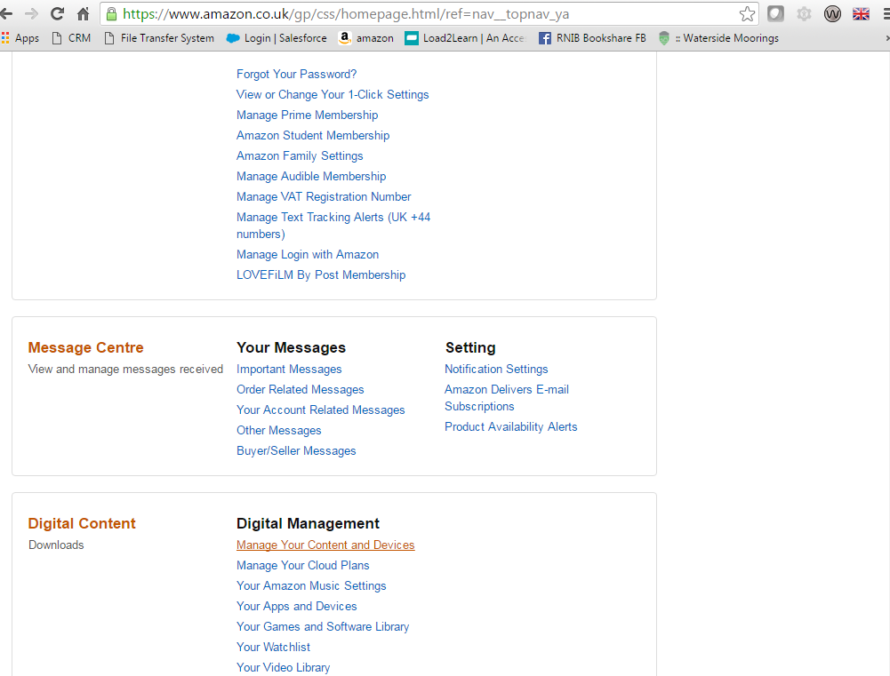

- From Settings tab, scroll down to Personal Document Settings
(Image below shows where ‘Send-to-Kindle E-mail Setting’ heading is on the webpage. Below s a list with headings ‘Name’, ‘E-mail address’ and ‘action’)
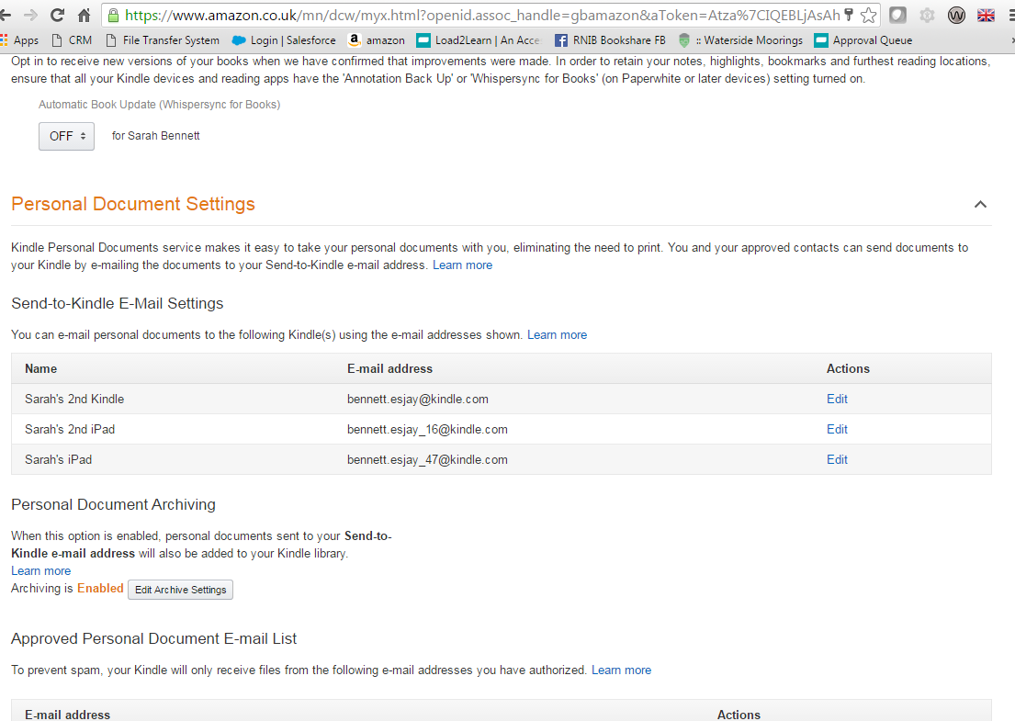

Add the Sponsors (staff or approved) email address
- (image shows that further down the webage is there is a link labelled ‘Add a new approved email address’). Complete this section to add a new email address.
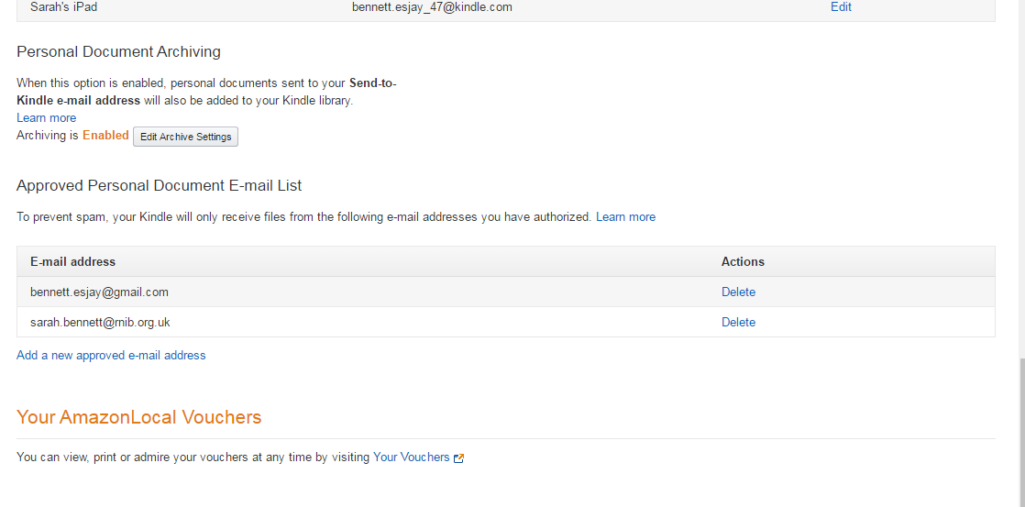

To send books to the Kindle App
- Download the required PDF title from RNIB Bookshare.
- Send an email from the Sponsors ‘approved’ email address now listed in the Members account to the members Kindle email address.
- Type “Convert” in the subject heading.

Depending on the size of the PDF/title the email can take up to an hour to be converted and come through into the members kindle library.

The member should ‘sync’ their Kindle library to see the new book – see diagram below. The title will appear with the email address from whom it was sent (Sponsors) underneath it – see diagram below
- Sync the Kindle library. (Image shows a Kindle library page, highlighted is a title with email address from sender. At the both of the page is a ‘Sync’ tab to select.)
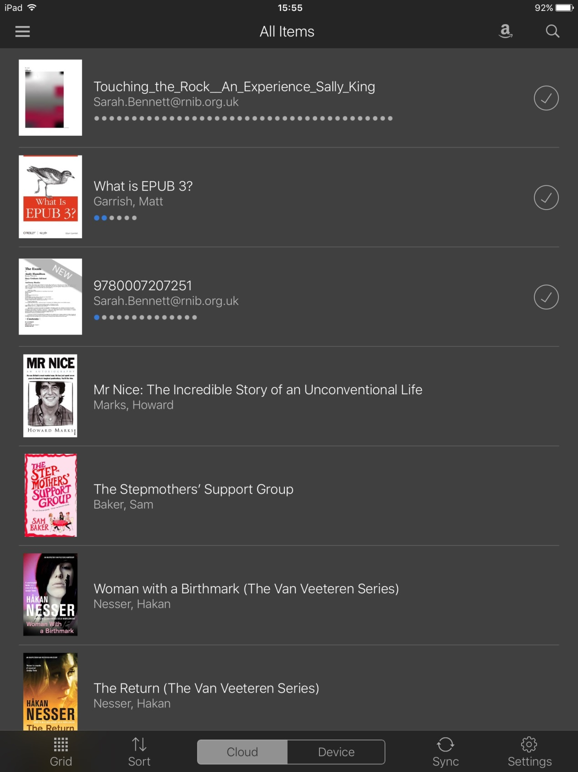

- Increase font size which will automatically reflow the text. (Image below shows the ‘view options’ that appear when selecting the ‘Aa’ tab. In ‘View options’ select wither the ‘Aa>’ or ‘Aa<’ buttons until text is at required size.)

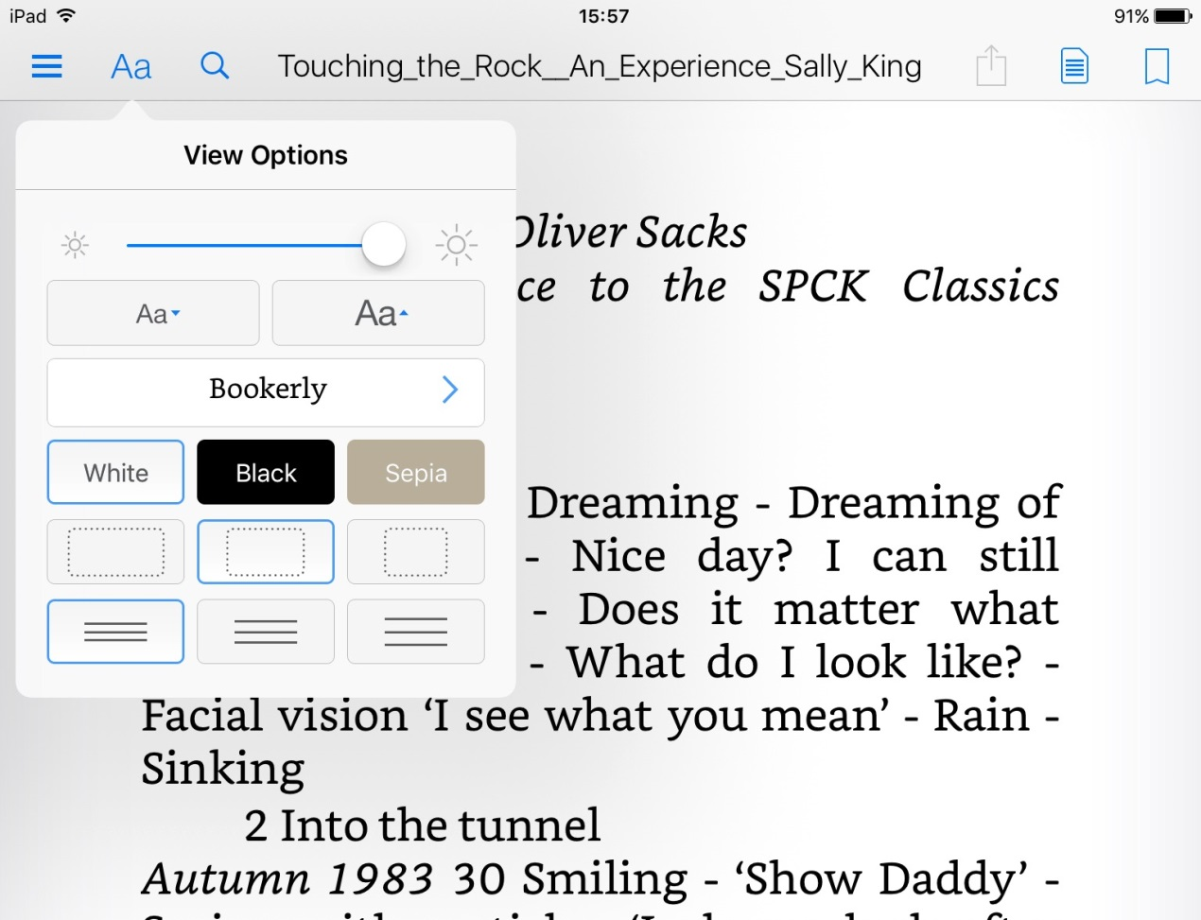

Where next?
Further information on producing accessible electronic documents is available on the RNIB UK education collection website, www.rnibbookshare.org.

RNIB Bookshare contact details
RNIB Bookshare Team
t: 0300 303 8313 (Freephone)
e: RNIBBookshare@rnib.org.uk
w: www.rnibbookshare.org
a: RNIB Bookshare, c/o RNIB, PO Box 173, Peterborough, PE2 6WS

Facebook: facebook.com/RNIBBookshareUK
Twitter: @RNIBBookshare

