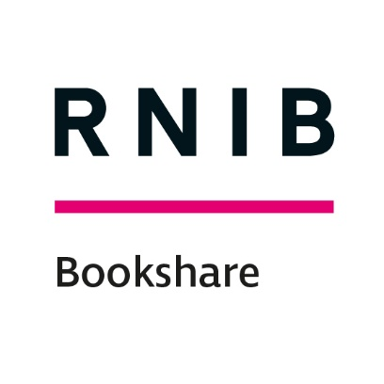

RNIB Bookshare: manual book submission volunteer level 1

Getting started
To submit books to RNIB Bookshare UK Education collection:
- Go to www.rnibbookshare.org
- Go to ‘My Homepage’
- Select ‘Volunteer Home’ from the left menu.
- Select 'add books to the collection' to access the 'Add a Book' page.

If you are not taken to the ‘Submit a Book’ information page, please contact us (EdCollection@rnib.org.uk) and we will set up the ‘Volunteer Level 1 Permissions’ on your account.

Please note: Any boxes that you are not directly referred to in this guide can safely be ignored.

File types accepted
We accept book files in EPUB2, EPUB3, RTF and PDF. We can use your EPUB or RTF file to automatically make the title available in a range of accessible formats. Where you supply a PDF only, the book will only be available to download by our members as a PDF.

Step 1: Upload the File
- Select file by clicking ‘Choose file’ and navigating to the file location on your computer.
- Leave scan quality as 'excellent'.
- Add an ISBN 13 (no spaces or dashes) which enables the system to pre-populate some of the metadata boxes.
- Comments box – add any relevant information, such as ‘scanned PDF put through OCR’ or you can leave this blank.
- Select ‘Next’ (the page will change automatically change once the file has uploaded).

Step 2: General Book Information
- Add any related ISBN 13s (no spaces or dashes) where known.
- Complete the following metadata fields (these should auto-fill, you will just need to edit/add information where necessary):
  - Title
  - Author(s)
  - Subtitle etc. (where appropriate)
  - Publisher
  - Synopsis

- Language should be already set as English (change for foreign language books).
- Select ‘Next’.

Step 3: Distribution Rights
- Select appropriate 'Copyright License' box.
- For copyrighted files add 'Holder', 'Year' and 'Country of Origin' (default UK).
- 'Country Availability' is default United Kingdom.
- Select ‘Next’.

Step 4: Classification
- 'Categories' - at least one needs to be added if not already populated by the system.
- You can select 'Back' at any stage to check input.
- Select 'Submit'. A confirmation page will summarise some of the book information you have submitted.
- Select 'Add another book' or ‘Submit a Book’ to restart the process!

The book will then be sent to the RNIB Bookshare team, where the file and metadata will be reviewed. The file will be either approved or rejected.
- Approved: The book will be live on the site and you will receive an email notification.
- Rejected: You will receive an email containing the reason for rejection (missing metadata, poor quality, corrupted file etc.).

Other stuff

What is an ISBN number?
ISBNs are 10 or 13 digit codes identifying specific editions of a book. They're sometimes written with hyphens.

ISBN codes are usually listed on a book's back cover, bar code, or copyright page. Searching by ISBN ensures that you find the exact edition you are looking for. Additionally, in this case it enables us to ask the publisher for the version/edition you need.

End of document

