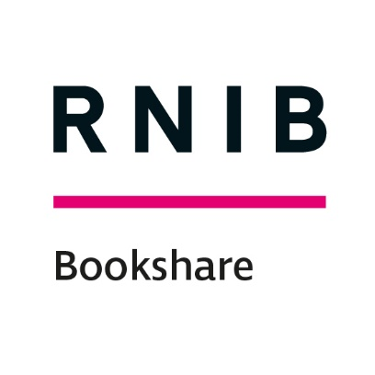

RNIB Bookshare: manual book submission

Contents
Getting started 1
Step 1: Preparing a file for upload 2
File types 2
Creating EPUB files (from Word) 2
EPUB creation software 2
Step 2: Upload the file 3
Step 3: General Book Information 3
Step 4: Distribution Rights 3
Step 5: Classification 3
Step 6: Complete process 4
Other stuff 4
What is an ISBN number? 4

Getting started
To submit books to RNIB Bookshare UK Education collection:
- Go to www.rnibbookshare.org
- Go to ‘My Homepage’
- Select ‘Volunteer Home’ from the left menu.
- Select 'add books to the collection' to access the 'Add a Book' page.

If you are not taken to the ‘Submit a Book’ information page, please contact us (EdCollection@rnib.org.uk) and we will set up the ‘Volunteer Level 1 Permissions’ on your account.

Please note: Any boxes that you are not directly referred to in this guide can safely be ignored.

Step 1: Preparing a file for upload

File types
We accept book files in EPUB2, EPUB3, RTF and PDF. We prefer to receive and EPUB file as this will ensure that the site can automatically make the title available in a range of accessible formats (Word, MP3, DAISY, BRF). Where you supply a PDF only, the book will only be available to download by our members as a PDF. The PDF should be text-recognisable, and not image based for it to have the most basic level of accessibility and used with access technology.

Creating EPUB files (from Word)
Creating a structured Word file is probably the most accessible format. It allows you to convert it into many other accessible formats whilst keeping contents, chapter headings etc that are so useful for access technology users.
RNIB Bookshare does not currently accept Word files, however it will create them from an EPUB file. By saving your structured word file into an EPUB format, all the structure and accessibility that you have created in word will be utilised in the automatically created files available at download to a member or sponsor.

EPUB creation software

DAISY Consortium WordToEPUB tool
The DAISY Consortium has created this free Word to EPUB tool (https://daisy.org/activities/software/wordtoEPUB/), you can download the tool and find out how to use it.

Calibre
Is a free open source conversion tool (https://calibre-ebook.com/). It is a very quick and easy process to convert your word file to an EPUB that you can upload to RNIB Bookshare.
- Run Calibre.
- Click ‘Add books’ choose word documents with .docx extension.
- Click on ‘Convert books’, at the output format pull-down list select ‘EPUB’.
- Click ‘OK’ for the conversion to take place. The new EPUB file will be saved to your device.

Step 2: Upload the file
- Select file by clicking ‘Choose file’ and navigating to the file location on your computer.
- Leave scan quality as 'excellent'.
- Add an ISBN 13 (no spaces or dashes) which enables the system to pre-populate some of the metadata boxes.
- Comments box – add any relevant information, such as ‘scanned PDF put through OCR’ or you can leave this blank.
- Select ‘Next’ (the page will change automatically change once the file has uploaded).

Step 3: General Book Information
- Add any related ISBN 13s (no spaces or dashes) where known.
- Complete the following metadata fields (these should auto-fill, you will just need to edit/add information where necessary):
  - Title
  - Author(s)
  - Subtitle etc. (where appropriate)
  - Publisher
  - Synopsis

- Language should be already set as English (change for foreign language books).
- Select ‘Next’.

Step 4: Distribution Rights
- Select appropriate 'Copyright License' box.
- For copyrighted files add 'Holder', 'Year' and 'Country of Origin' (default UK).
- 'Country Availability' is default United Kingdom.
- Select ‘Next’.

Step 5: Classification
- 'Categories' - at least one needs to be added if not already populated by the system.
- You can select 'Back' at any stage to check input.
- Select 'Submit'. A confirmation page will summarise some of the book information you have submitted.
- Select 'Add another book' or ‘Submit a Book’ to restart the process!

Step 6: Complete process
The book will then be sent to the RNIB Bookshare team, where the file and metadata will be reviewed. The file will be either approved or rejected.
- Approved: The book will be live on the site and you will receive an email notification.
- Rejected: You will receive an email containing the reason for rejection (missing metadata, poor quality, corrupted file etc.).

Other stuff

What is an ISBN number?
ISBNs are 10 or 13 digit codes identifying specific editions of a book. They're sometimes written with hyphens.

ISBN codes are usually listed on a book's back cover, bar code, or copyright page. Searching by ISBN ensures that you find the exact edition you are looking for. Additionally, in this case it enables us to ask the publisher for the version/edition you need.

End of document

