Guidance on using the Word Document Generator

Save the WordDocumentGenerator.zip file

Extract the files from the .zip folder (right click ‘extract all’) and save them in a location you will remember

Locate the .EXE file and double click on it

The application will open a window:
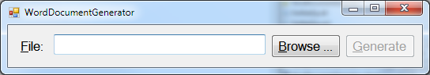

Click on ‘Browse’ and locate the DAISY file you have downloaded. It will be a .ZIP folder

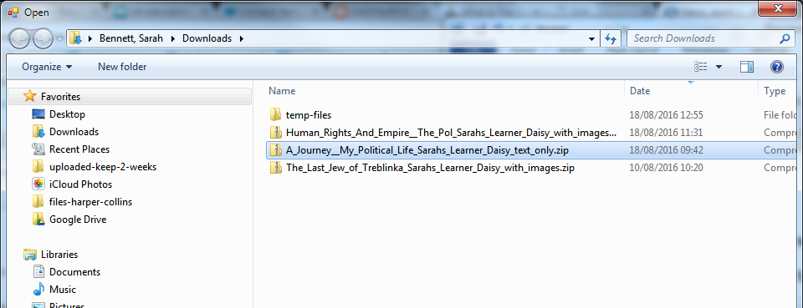

Click on generate

Navigate to your original folder where the ZIP folder resides

The newly created Word document will be in the same folder

