RNIB Bookshare: Downloading braille files

Supporting documents and systems 1
Set your learners (Members) preferences 1
Quick guide 4
Full guide with screenshots 5

Supporting documents and systems

RNIB Bookshare | www.rnibbookshare.org

Set your learners (Members) preferences

If you have a learner whose preferred format is braille, you can set their download preferences so that this always the first option offered to you when the source file is hosted as an EPUB. You will still have the option to change the download format to DAISY or MP3 is you wish to.

If the host file for the book is a PDF file, it can only be downloaded as a PDF.

If you have not yet set up your learner’s account guidance on how to do this can be found in our Help Centre.

- Log into your RNIB Bookshare account
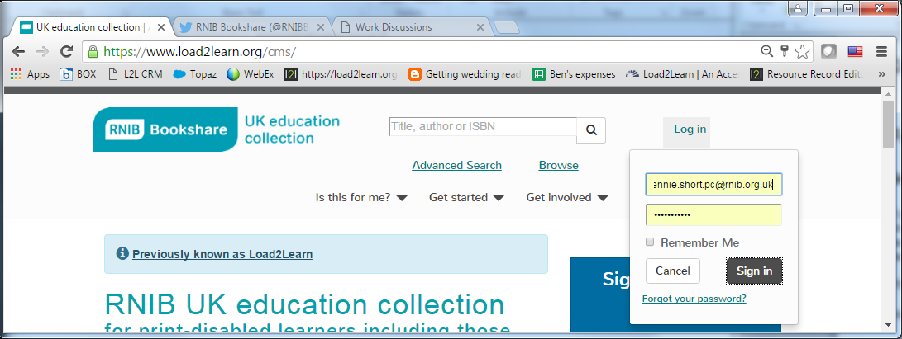

You’ll be taken straight to “My homepage”

- Select either “Members” or “Manage your list of learners (Members)”
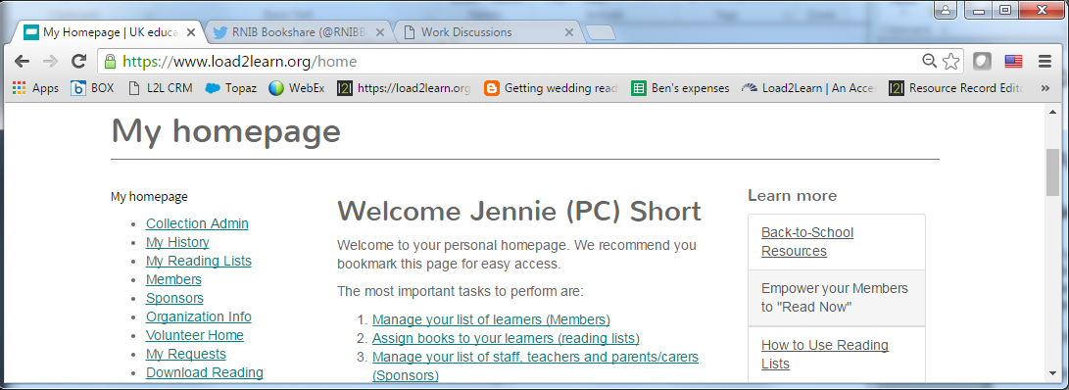

- Select the “Last name” of the learner’s account you wish to edit.
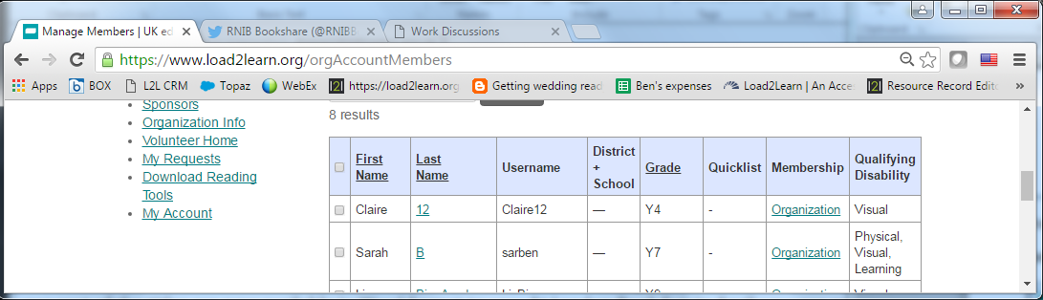

- Set the “default download format” to “Braille Ready Format (BRF)
- Set the “BRF size and format” to the required setting
- Set the “Braille Grade” to the required UEB setting
- Set the “BRF file extension” to the required setting
- Tick the check box and “Save”

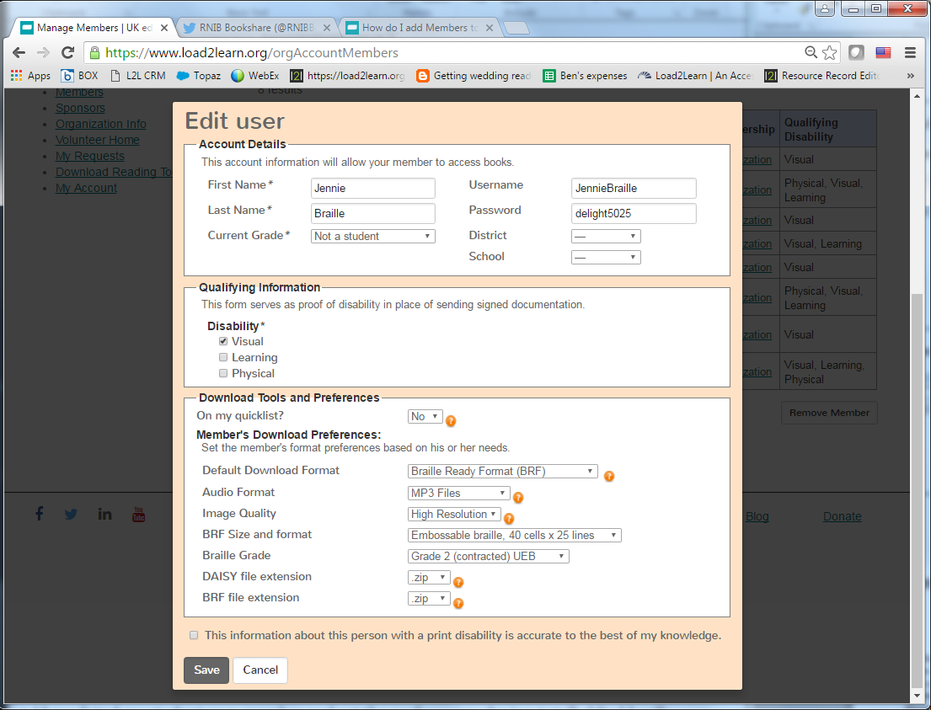

Quick guide

- Search for the book you need.
- If the book is available it will appear in the search results. You will need the EPUB file (that doesn’t have PDF after the title). Some books are available in both EPUB and PDF format.
- Select “Download”
- Check the box next to the learners you wish to download the book for
- Select “Download Books”
- Check and confirm the “Download”
- You’ll be taken to your “My history” page, showing your download history.
- The book status will be “in progress” and will change to “available”
- Select “Available”
- The file will be downloaded a zip file.
- Open the zip file to locate your BRF file
- You may need to extract the BRF file from the zip file before you can use it. To do this right click and select “extract all”
- The BRF file is no longer in a zip folder and is ready to use.

Full guide with screenshots

Downloading a braille file

Search for the book you need. The quickest way to find out if we have a book on the site is to type the ISBN into the Search box at the top of any page.

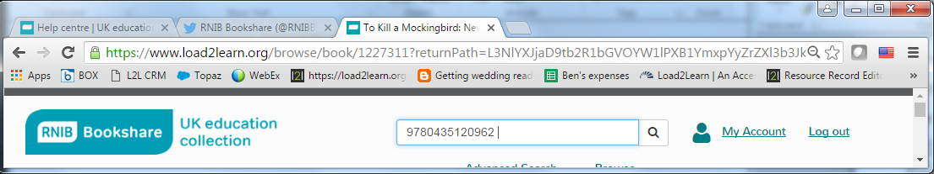

If the book is not available, you will be directed to the “advanced search” page where you’ll find the link to the “Book request form”

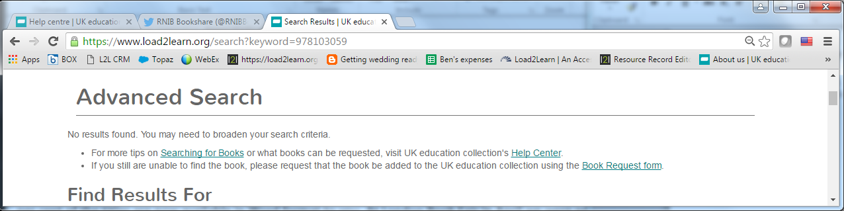

If the book is available it will appear in the search results.

Here the book is available as both an EPUB hosted file and a PDF. Note, not all titles will offer both options.
- To Kill a Mockingbird: New Windmills
- To Kill a Mockingbird: New Windmills (PDF)

You will need the EPUB file (that doesn’t have PDF after the title).

Select “Download”

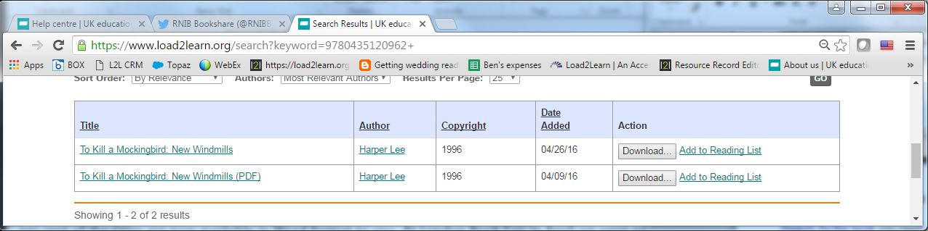

You’ll be presented with you list of learners (Members) with their “Download format” showing their preference. If you need to change the download format, simply choose the required format from the drop down menu.

If your learners preference is set to Braille Ready Format “BRF” will appear automatically in the “Download format” box.

Check the box next to their name (first column).

You can download the book for multiple learners.

Select “Download Books”

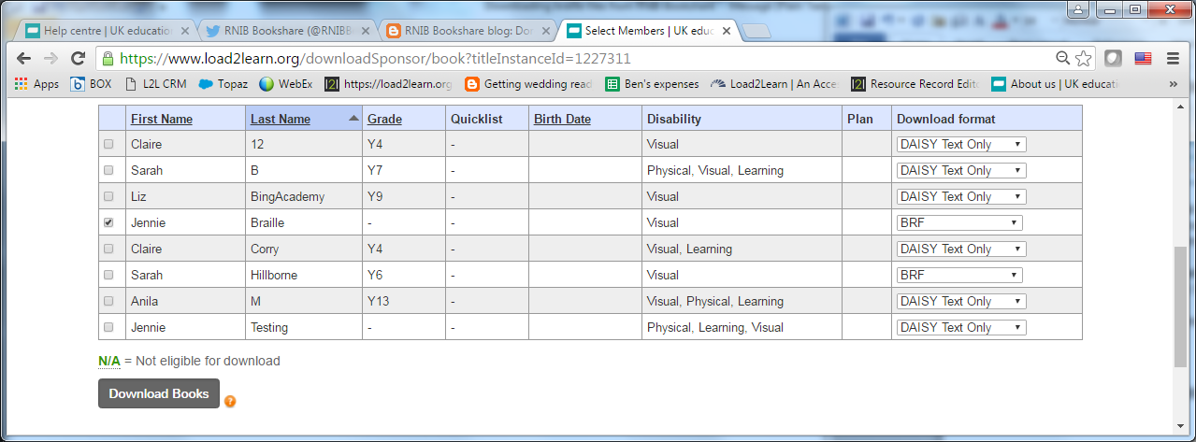

Check and confirm the “Download”

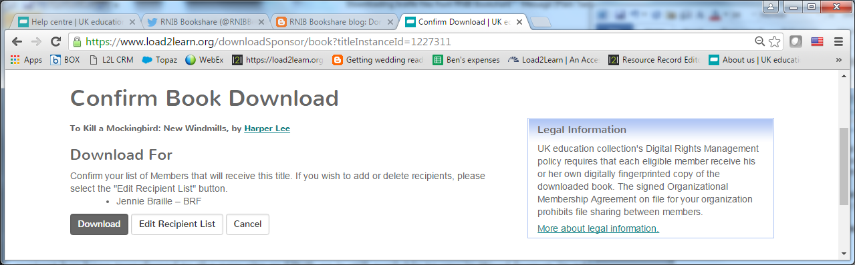

You’ll be taken to your “My history” page, showing your download history.

The book status will be “in progress”

Once the book is ready the status will change to “available”

Select “Available”

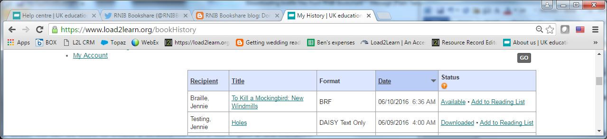

The file will be downloaded a zip file. This may appear at the bottom of your browser window or go directly to your downloads folder.

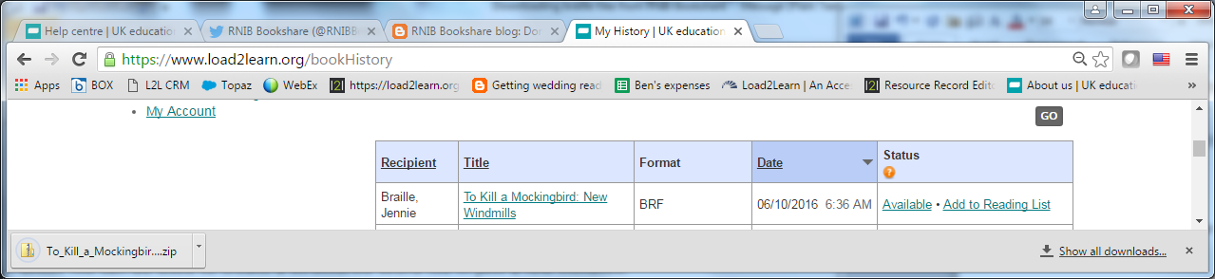

Open the zip file to locate your BRF file

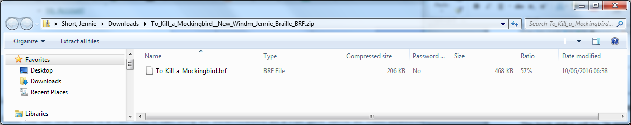

You may need to extract the BRF file from the zip file before you can use it.

To do this right click and select “extract all”

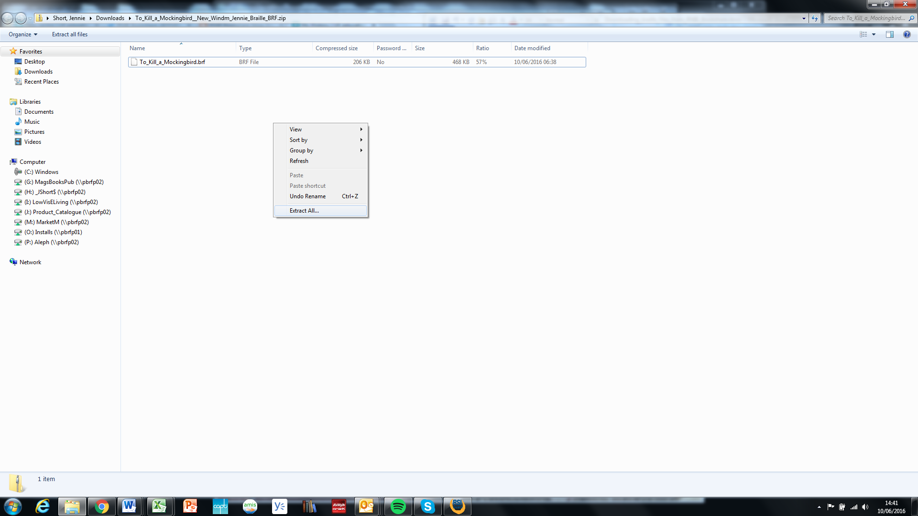

Select the location where you wish to save the file and “extract”
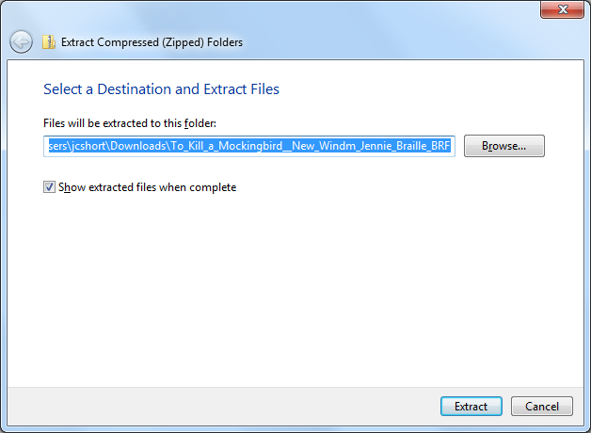

The BRF file is no longer in a zip folder and is ready to use.

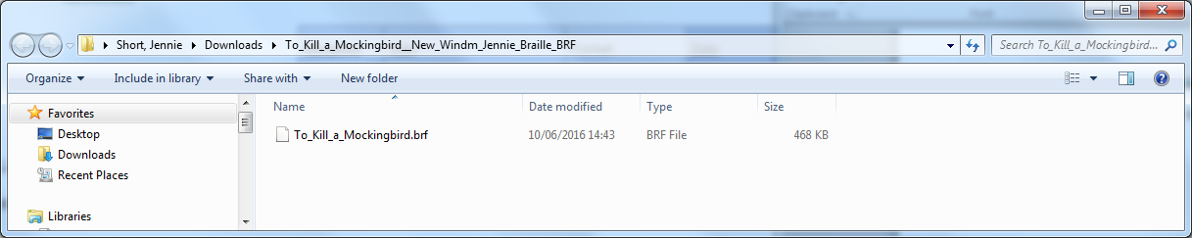

---
Author: RNIB Bookshare
Date created: 10 June 2016
Last amended: 10 June 2016, Version 1
Saved: M:\RNIB Bookshare\Guidance and training for customers\Braille Ready Format (BRF)\Downloading_braille_files_from_RNIB_Bookshare.docx

