Downloading a book from RNIB Bookshare onto Humanware Victor Reader Stream

Download and assign a book to a learner (member)
Log in to your UK education collection account.
Search for a title.
Select “Download.”

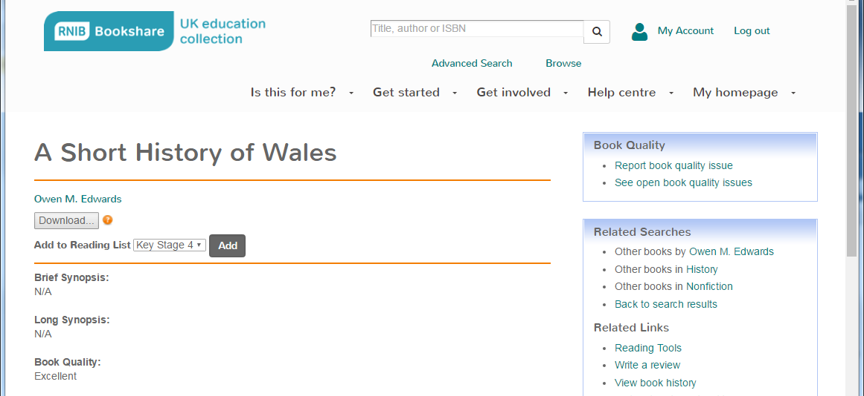

Check the box to the left of the student's name for download.
Select “DAISY Text Only” for your download.
Select the box on the bottom of the page that says “Download.”

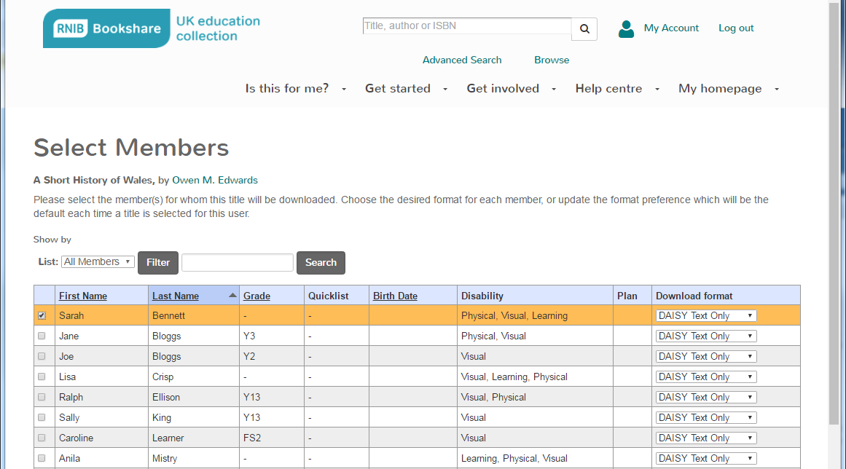

Select “Download” again.
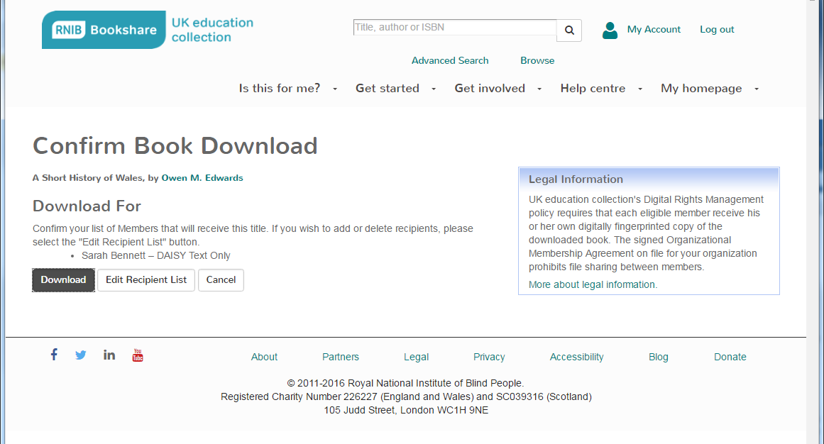

Select “Available” under “Status.”

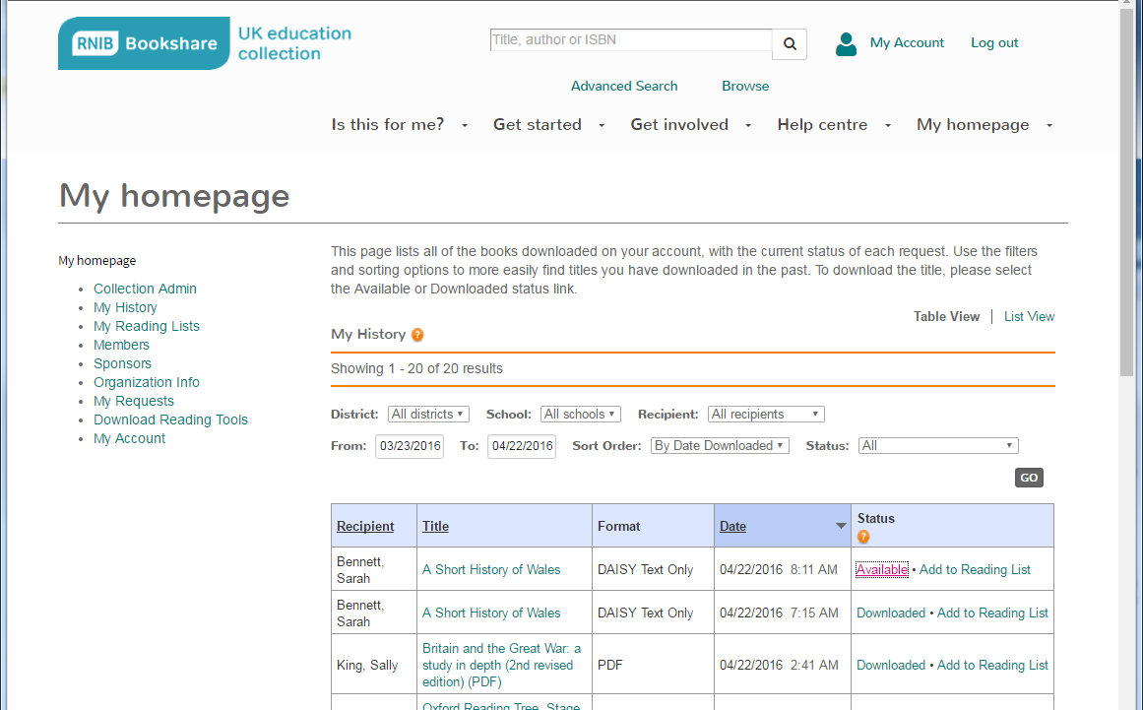

The file will now download to your ‘Downloads’ folder

Unzip or extract the files
Select the .zip book file (right click).
Choose ‘Extract All’ from the File menu.
Choose a location for saving the files.

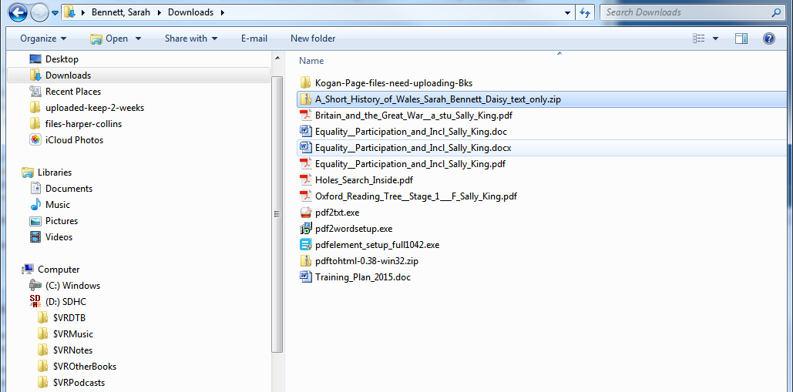

Copy files over to Victor Reader Stream

Remove the SD card from the VRS

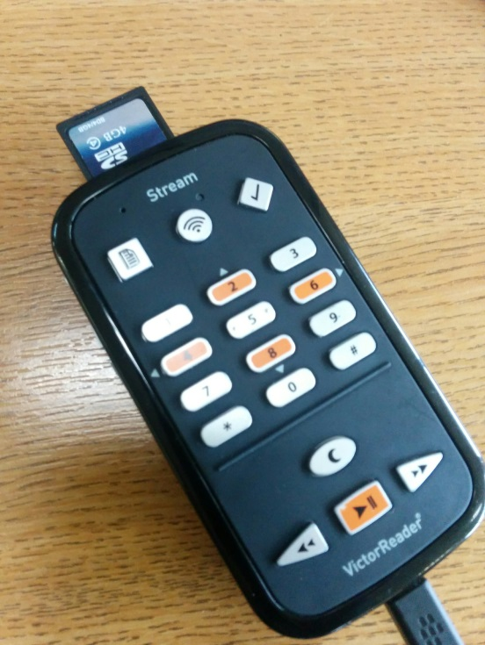

Insert into PC/laptop

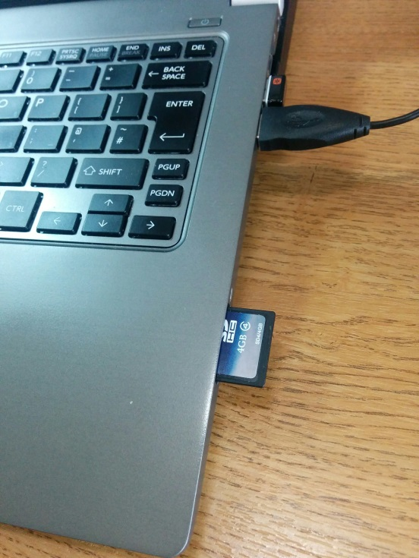

Select all and copy the extracted files from your PC, paste into the folder $VRDTB folder on the SD card

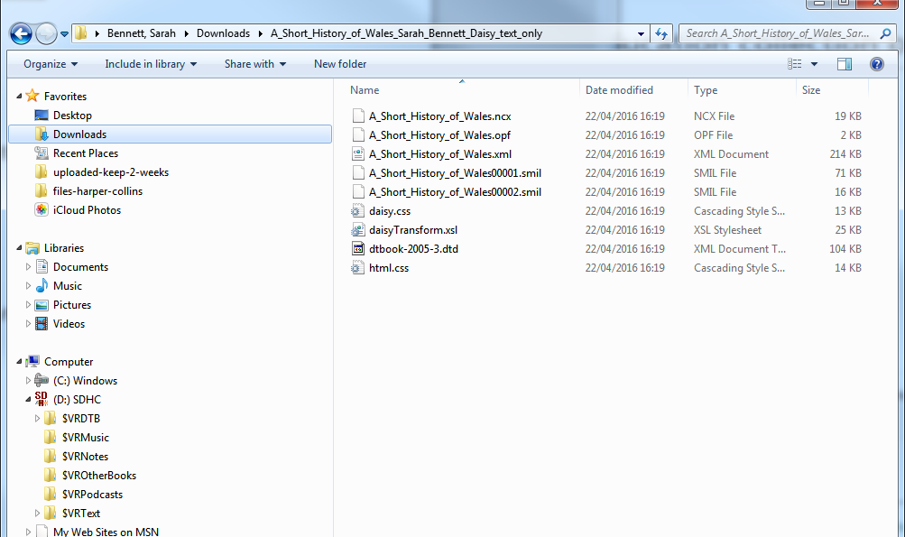

Remove the SD card and replace into Victor Reader Stream. The device will automatically pick up new files once it’s reinserted and switched on.

RNIB Bookshare contact details
RNIB Bookshare Team
t: 0300 303 8313 (Freephone)
e: RNIBBookshare@rnib.org.uk
w: www.load2learn.org
a: RNIB Bookshare, c/o RNIB, PO Box 173, Peterborough, PE2 6WS

Facebook: facebook.com/RNIBBookshareUK
Twitter: @RNIBBookshare

