RNIB Bookshare: Converting DAISY files to read on a Kindle

Download the book in the "DAISY with images" format (if “DAISY text only” is the only DAISY download option offered the original EPUB file doesn’t contain images).
- Download the DAISY file. (image below shows selection of the ‘download’ button on RNIB Bookshare)

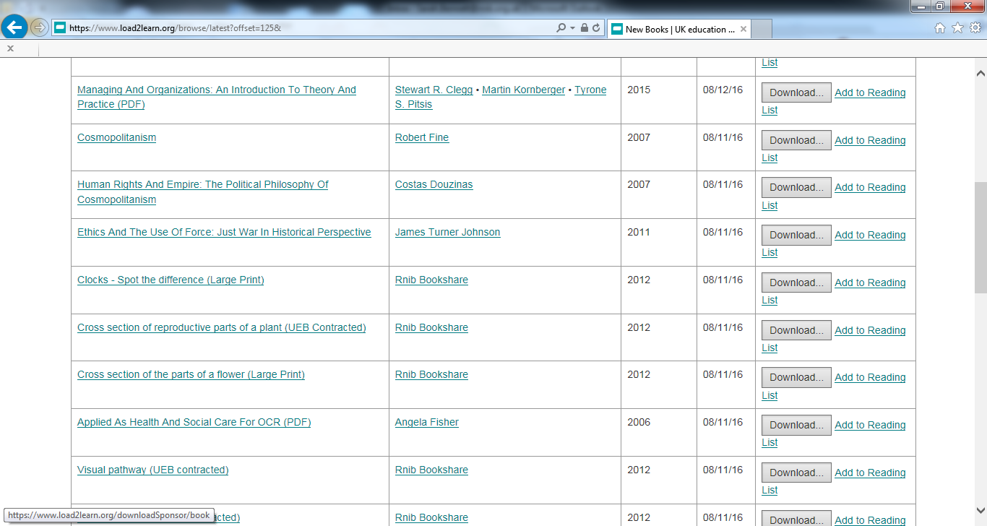

- Assign to your learner. (image below shows list of learners/members on RNIB Bookshare, selecting tick box in 1st column)
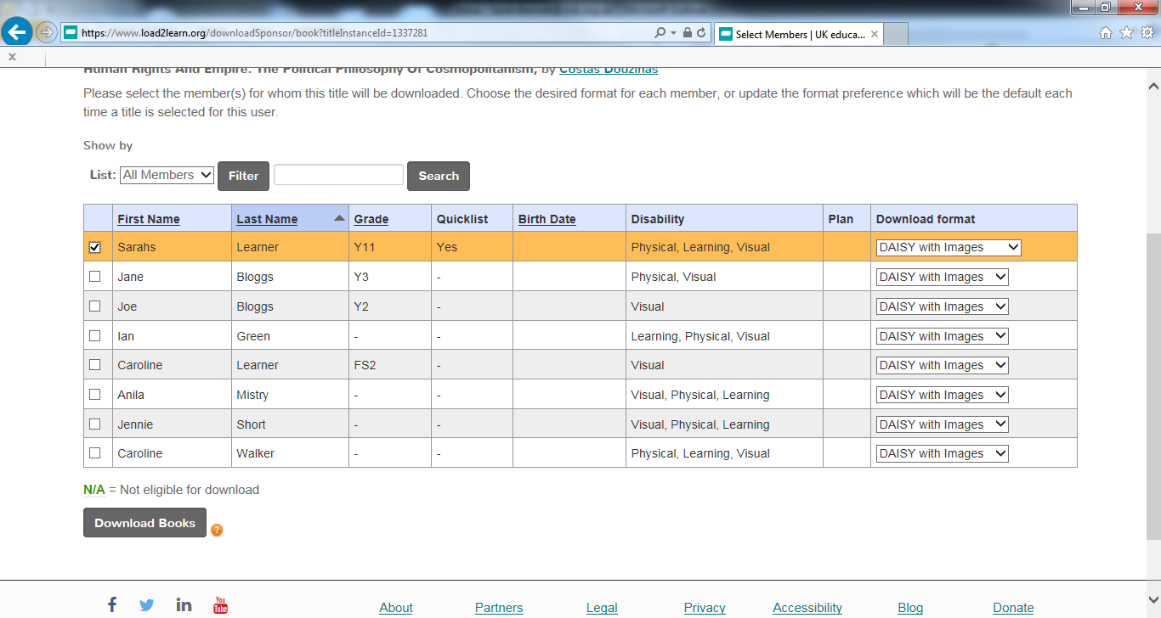

- Confirm download (image below shows selection of the download button’ once member has been assigned).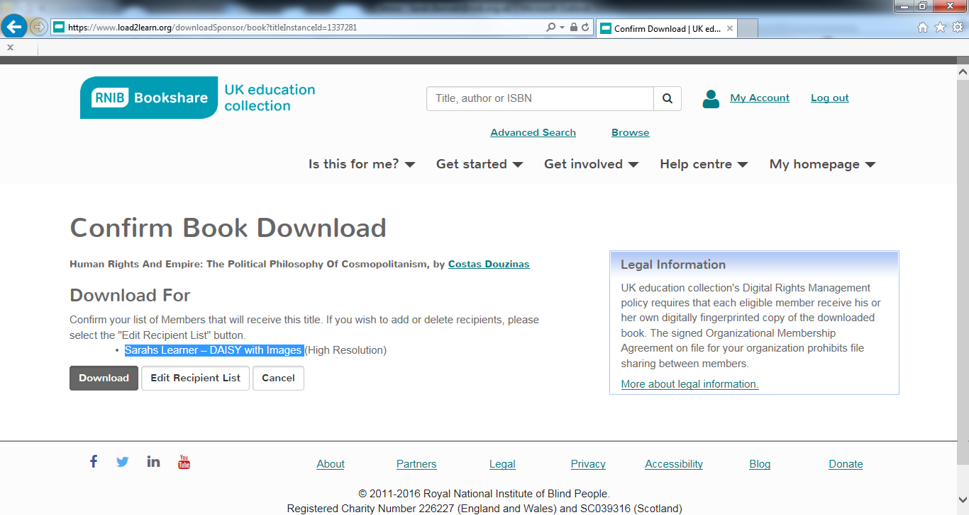

- Wait until ‘In Progress’ changes to ‘Available’ (image below shows the ‘in progress’ status in the final column of the Recent books section of the members homepage).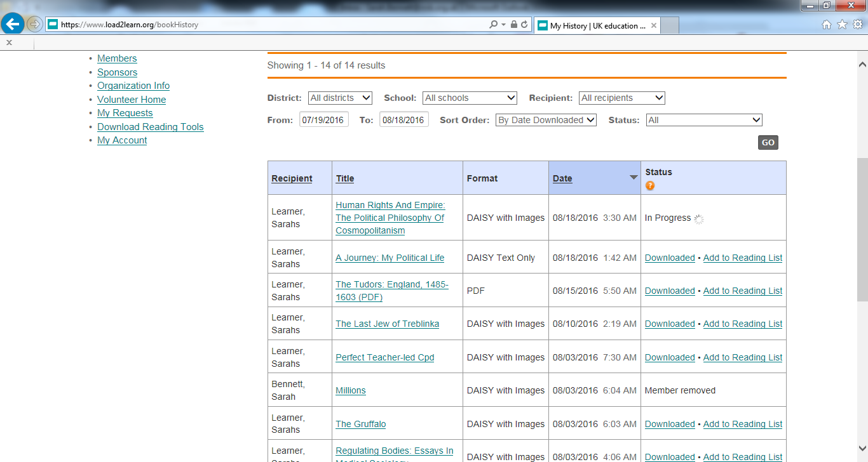

- Click on ‘Available’ and select ‘Save’ (image below shows selection of the available link in the final ‘status’ column, and then selecting the option to ‘save’)
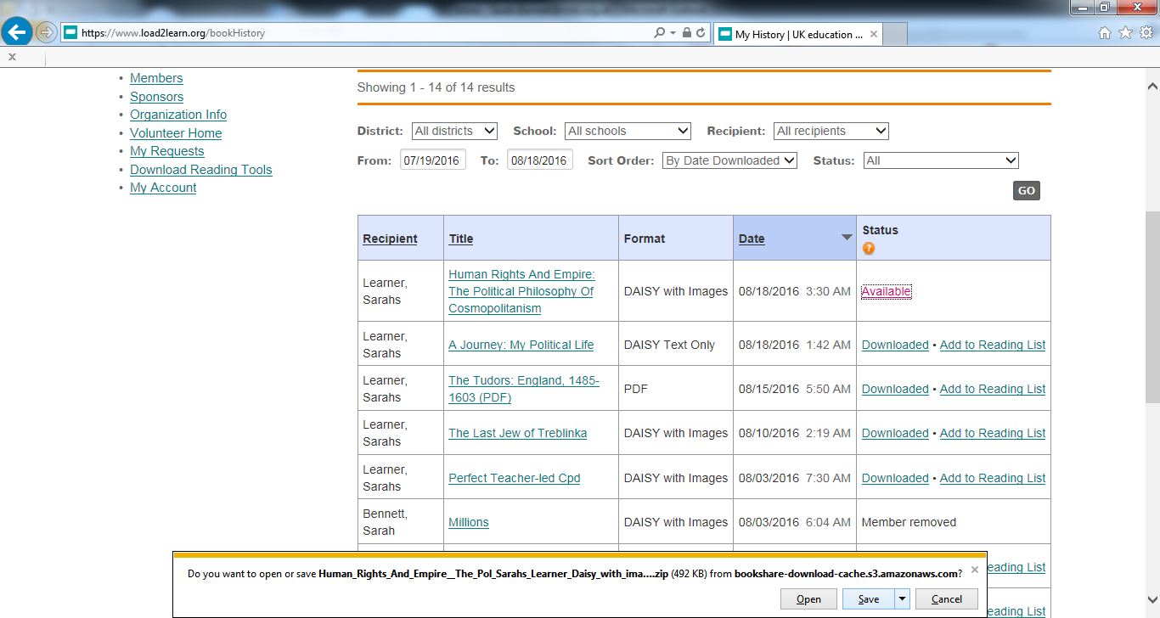

- Once downloaded select ‘Open folder’ (image below shows message that allows the options to ‘open’ ‘open folder’ ‘view downloads’).
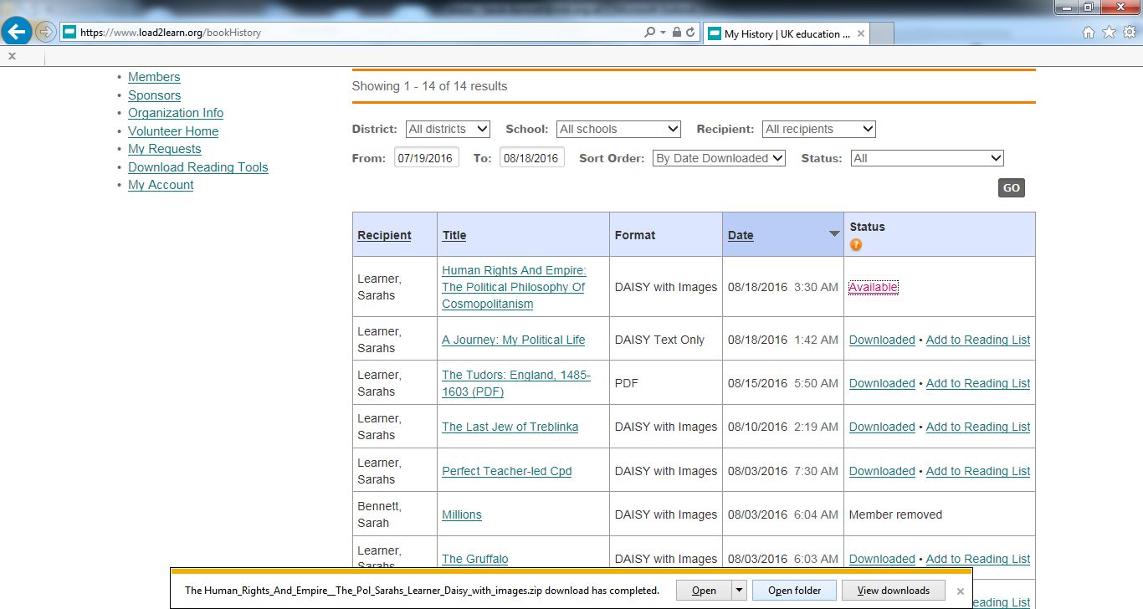

- Locate your downloaded ZIP folder (usually in ‘Downloads’ folder), right click and choose to ‘extract all’.
(Image below shows a device downloads area, the title required is highlighted).
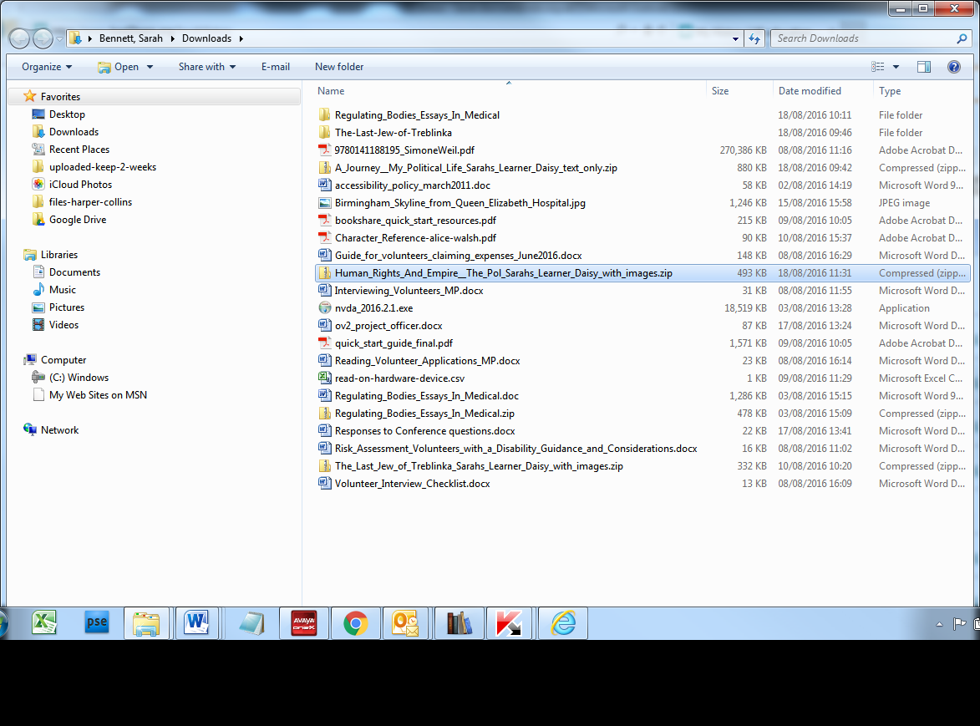

- Within the folder of extracted files, locate the .XML file, right click to rename. (image below shows a highlighted xml file in the table of files from within the extracted files folder).
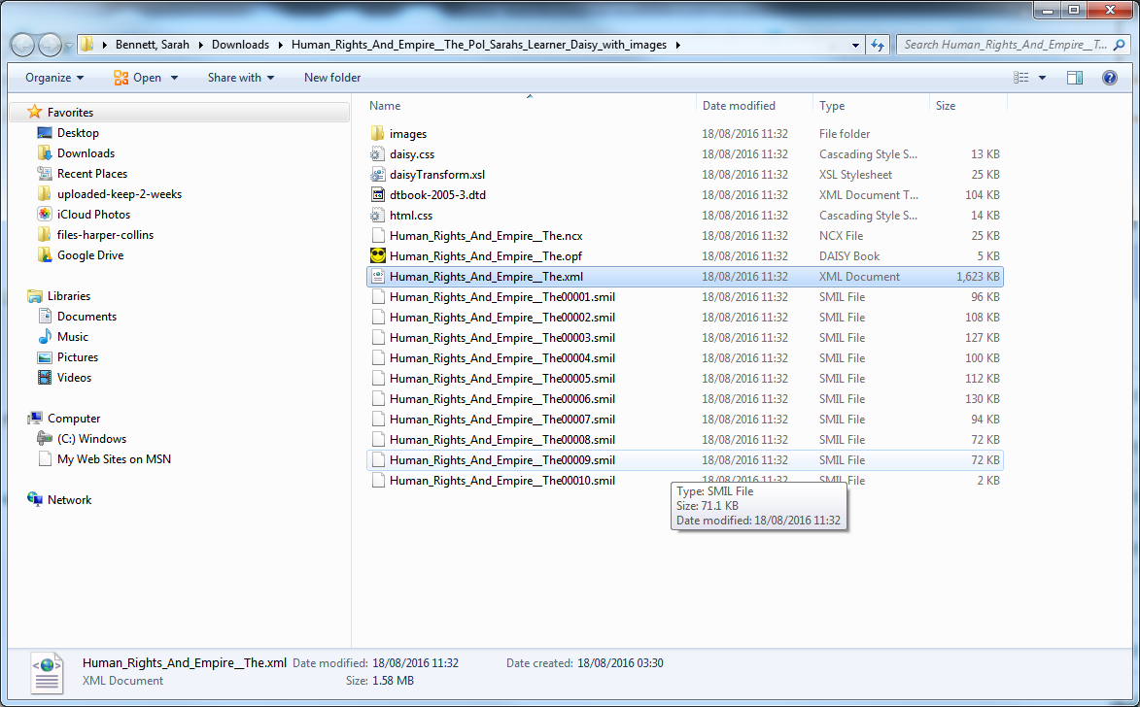

- Rename the extension .XML to .HTML Ignore warning. (Image shows text ‘If you change a file name extension, the file might become unstable. Are you sure you want to change it. ‘Yes’ button is selected)
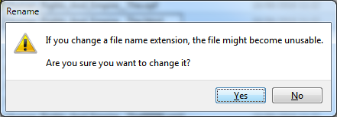

- Open Calibre and click on ‘Add books’ (Image shows Calibre software home screen with various icons across the top. The ‘add books’ tab is highlighted.
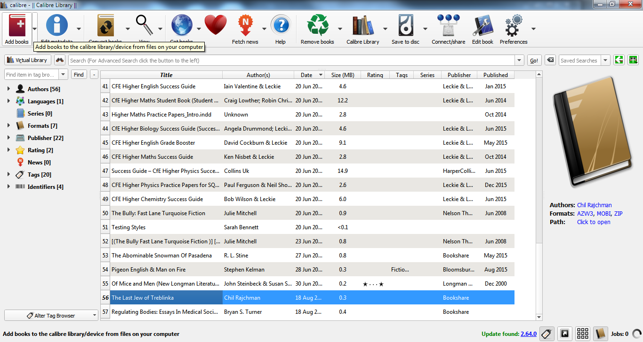

- Navigate to your .HTML file on your device, select open. (image shows the extracted folder location)
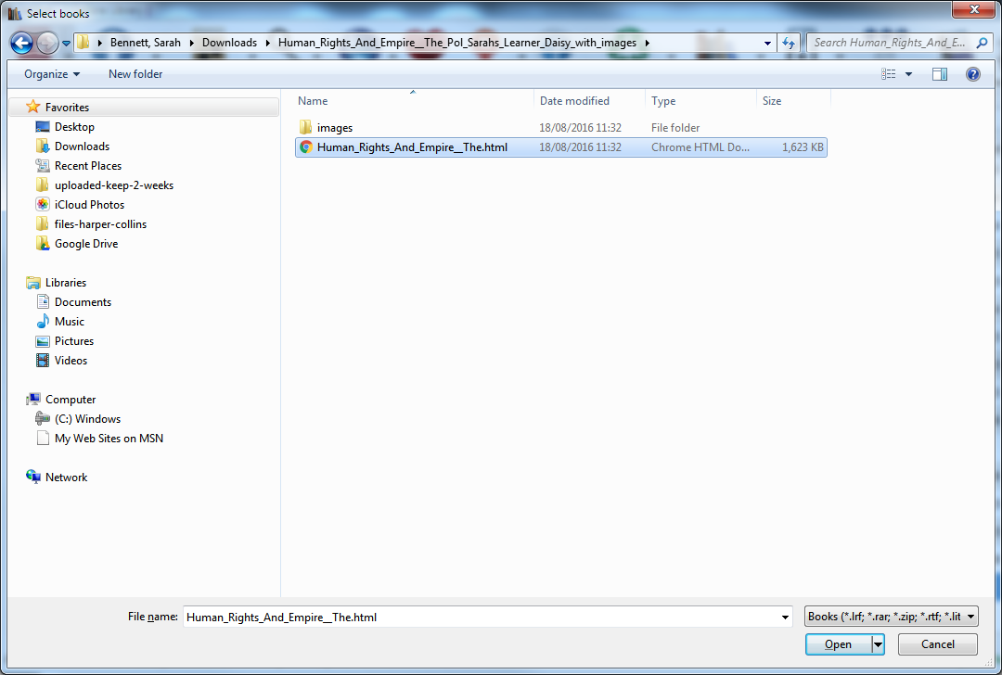

- The book will load into the library, select Edit metadata. (image shows Calibre homepage, the ‘edit metadata’ icon is highlighted, it’s the 2nd icon on the taskbar at the top of the page)

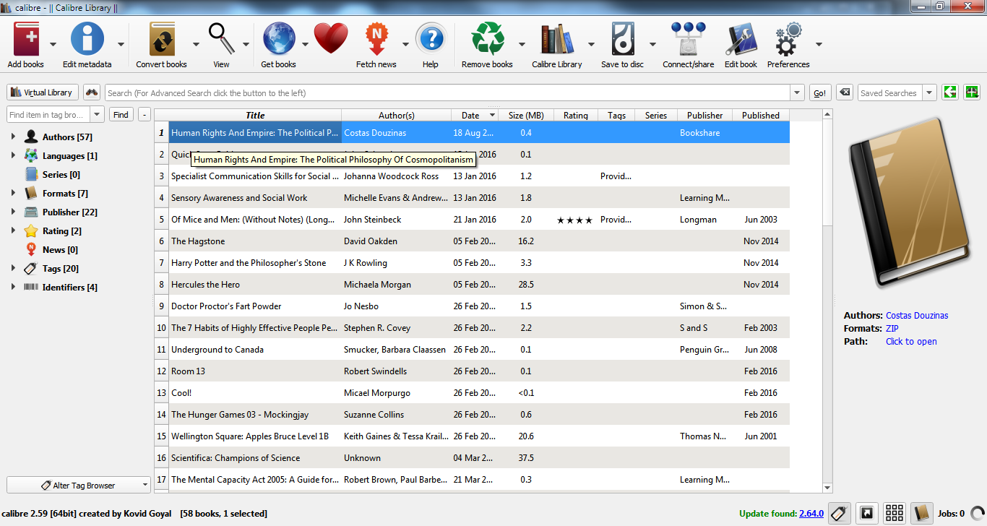

- Click on Download metadata to tidy up any missing elements. (image below shows the ‘edit metadata’ page in Calibre. There is a highlighted button marked ‘download metadata’ near the bottom of the page).
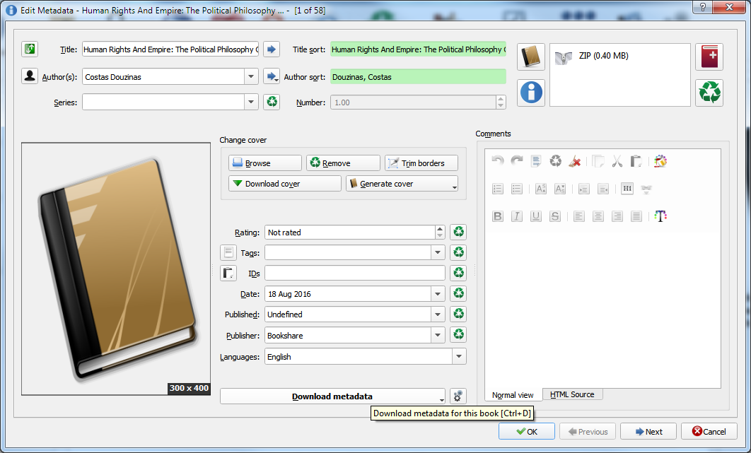

- The application will search the internet for any missing data. Select correct edit of the book. It will then download missing front covers et. Where necessary select OK (Image below shows Calibre downloading metadata page with book cover files showing)
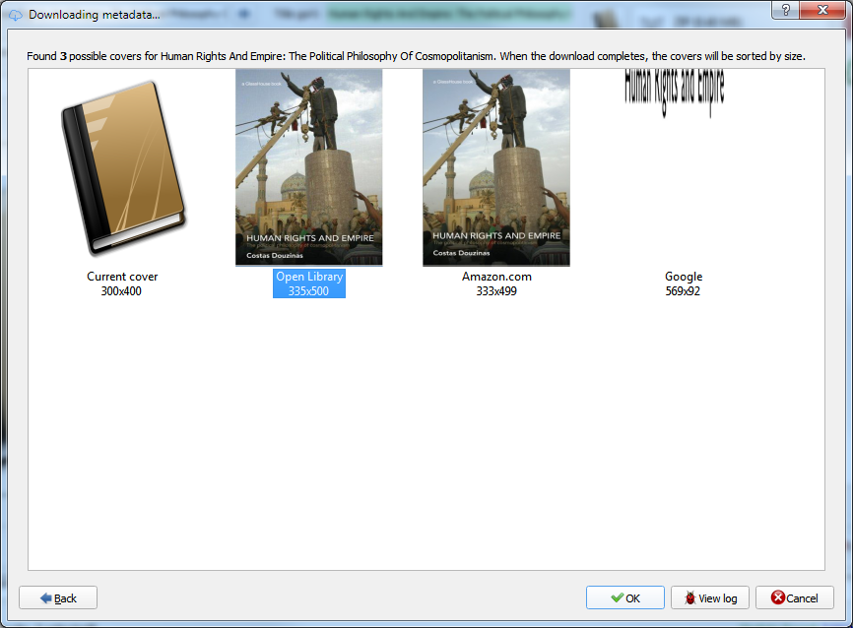

- ISBN and any other metadata now automatically added, select ok. (image below shows Calibre downloading metadata page with ‘OK’ button highlighted).
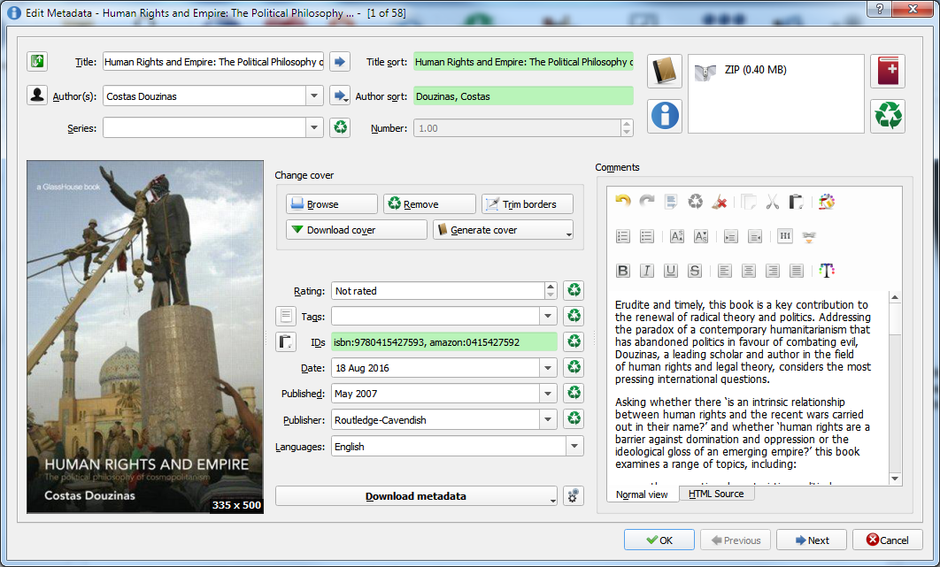

- Click on ‘convert books’ (Image shows Calibre homepage, the ‘convert books’ icon is highlighted, it’s the 3rd icon on the taskbar at the top of the page)
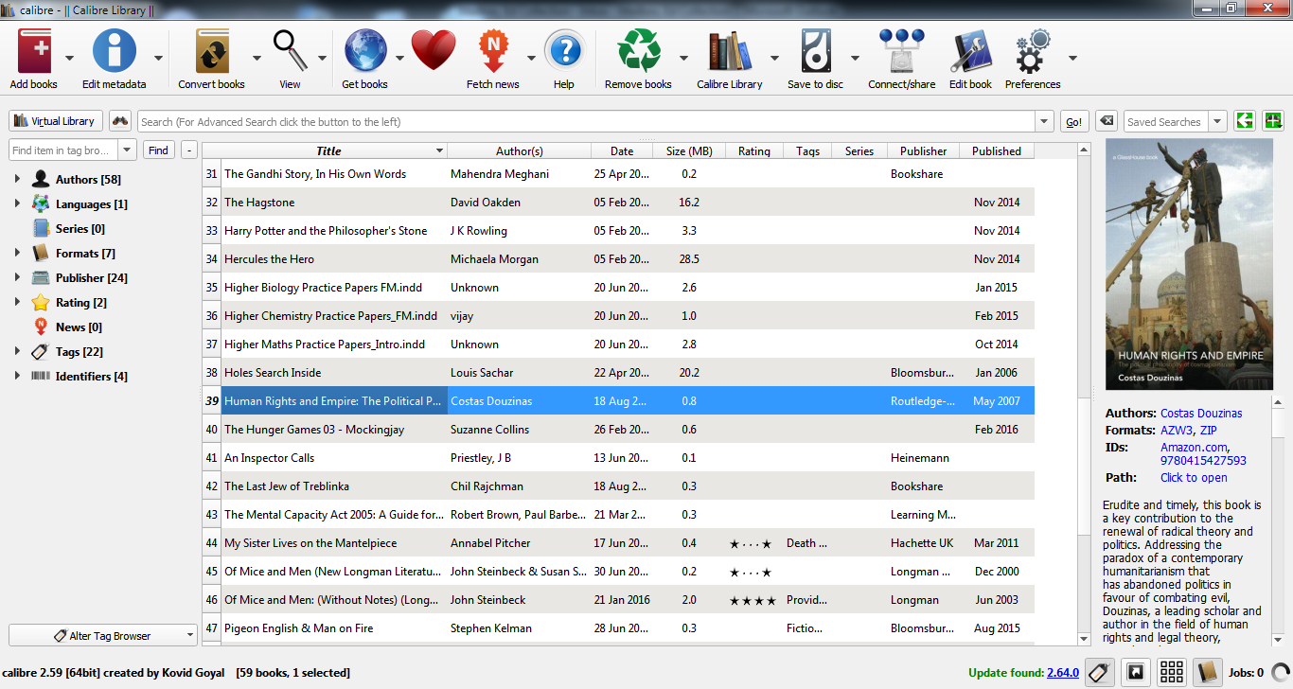

- For the Output format far right choose AZW3, select ‘ok’ at the bottom right of the page. (Image shows Calibre convert books page, at the top right hand side of the page is an ‘output format’ drop down options. ‘AZW3’ is selected).
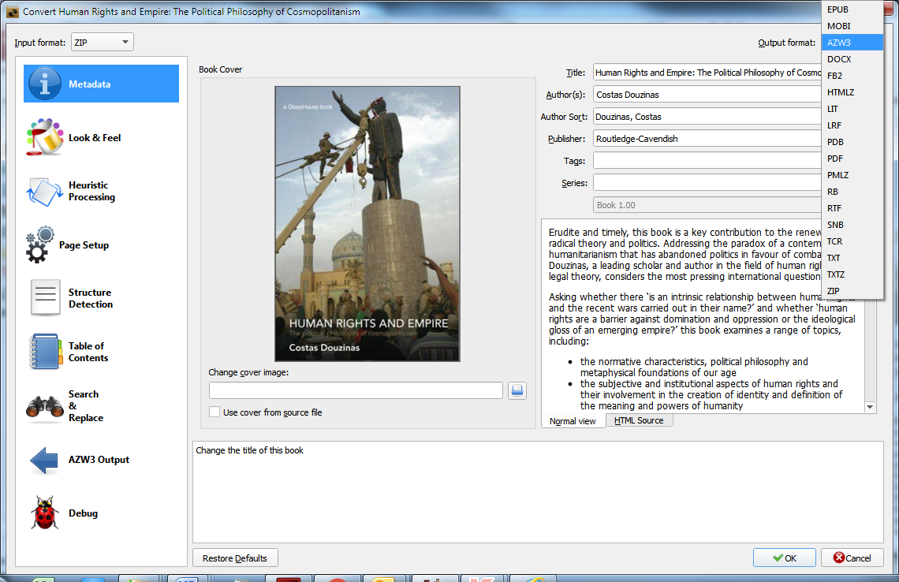

- New file formats are now listed under book cover (right hand side column). (Image shows Calibre homepage, there are a list of titles, on highlighting the title required, the details box on the right hand side on the page shows basic metadata including various file formats).
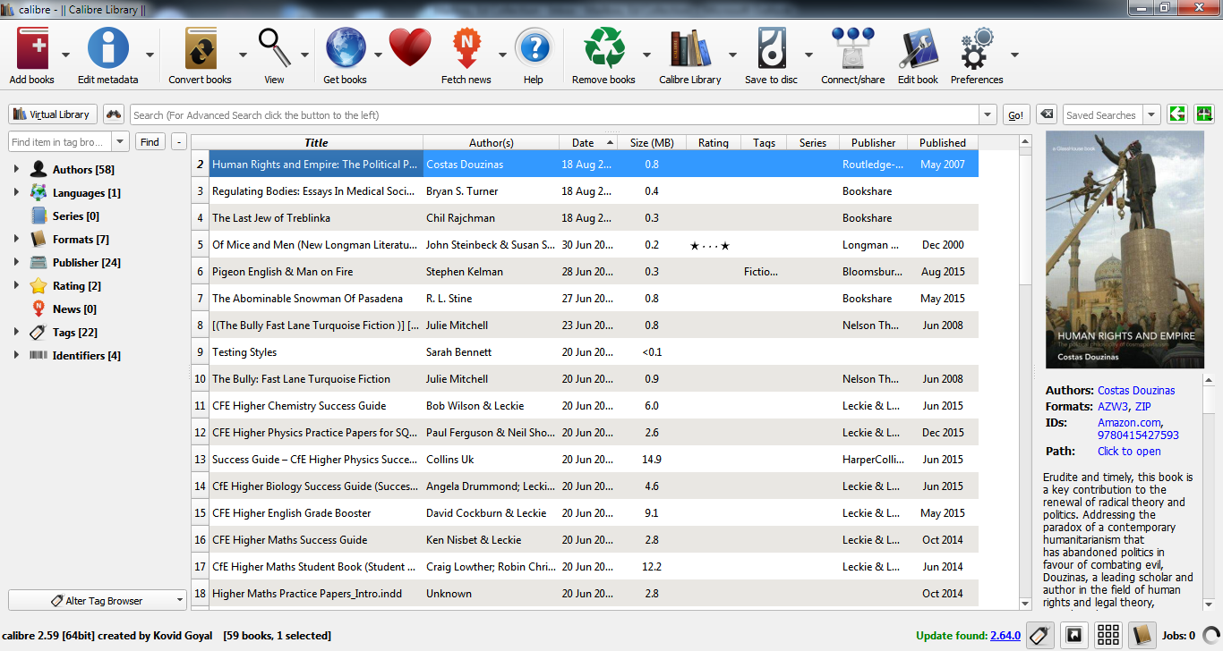

- Plug the Kindle into the PC/laptop – it will recognise the device (Image shows Calibre homepage, the 7th icon in the taskbar is ‘Device’, it will provide a selection to choose from from a drop down option)
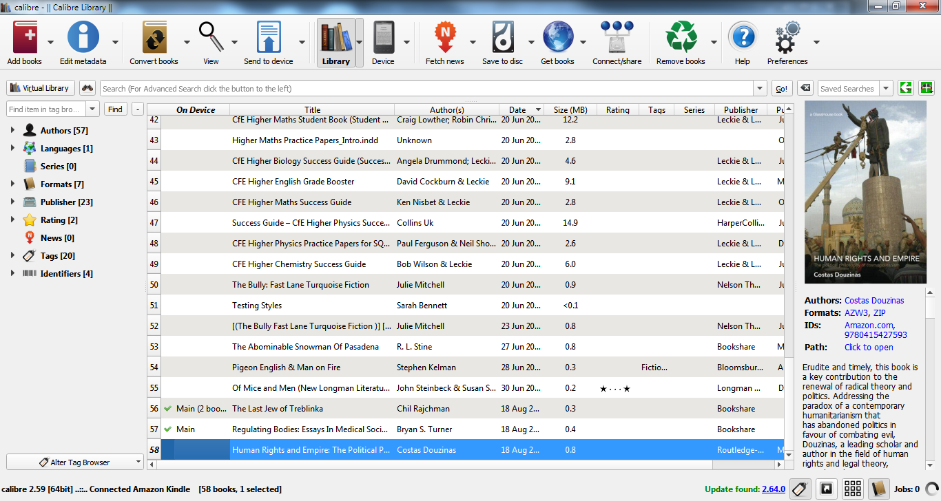

- Click on ‘send to device’, and then Safely the remove device from your PC.

The title will then be synced onto the Kindle where the font, background colours and voiceover can be used (depending on the Kindle version)

(image below shows a Kindle device with book choices available in the library area.)
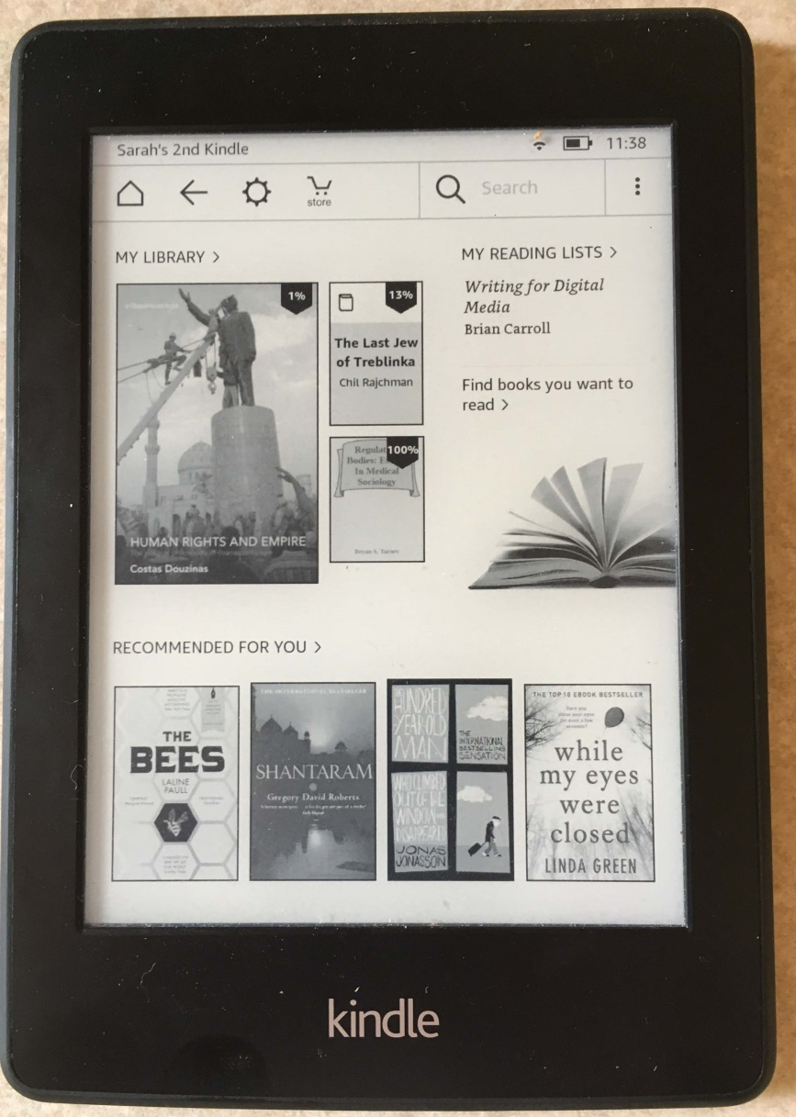

End of document

