Creating Word documents from
DAISY files on a mac

Supporting documents and systems 1
Full guide with screenshots 1

Supporting documents and systems

RNIB Bookshare | www.rnibbookshare.org
RNIB Bookshare | Creating styled documents in Word 2010: a guide to making text more accessible
RNIB Bookshare | Guide to modifying structured Word documents

Full guide with screenshots

Search for the book you wish to download.

The quickest and easiest way to do this is to type the ISBN into the search field at the top of the site.

If the title appears in the search results twice, it is the entry that does NOT have (PDF) in the title that you want to download.

Select “Download”

Check the box next to the learner you’re downloading the book for

Select the download format “DAISY with images”

Select “Download books”

Confirm the “Download”

Once the download is complete, the status will change to “Available”

Select “Available” to download the zip folder containing the files.

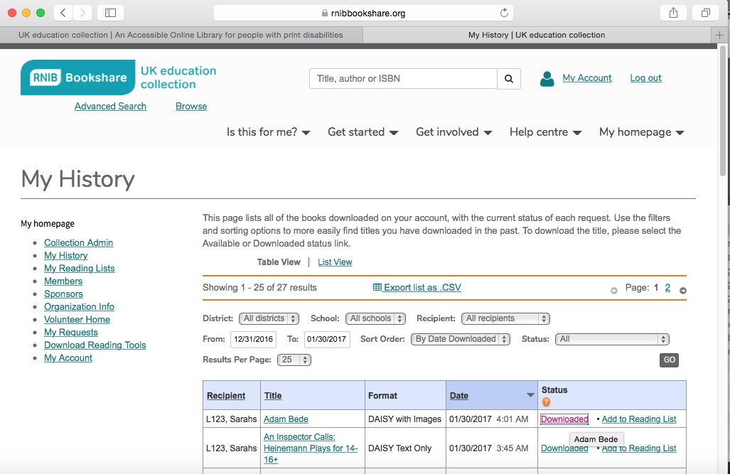

Navigate to your “Downloads” folder

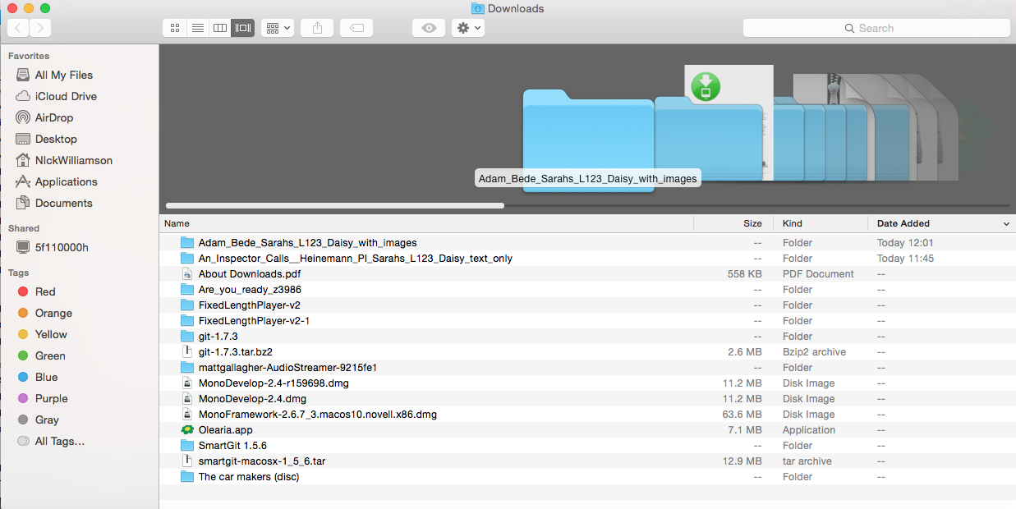

On downloading the zip folder is automatically decompressed (extracted) and put in trash with the extracted files placed in the downloads folder.

If this doesn’t occur check in the settings in Safari > General
to ensure that ‘Open “safe” files after downloading” is checked:

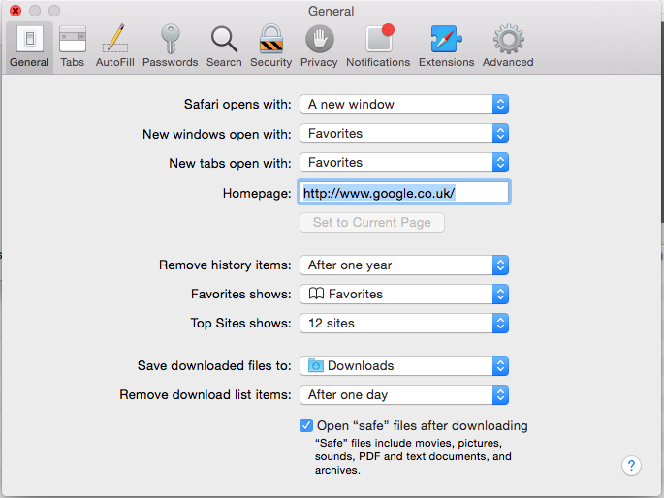

Locate the “book_title.xml” file.

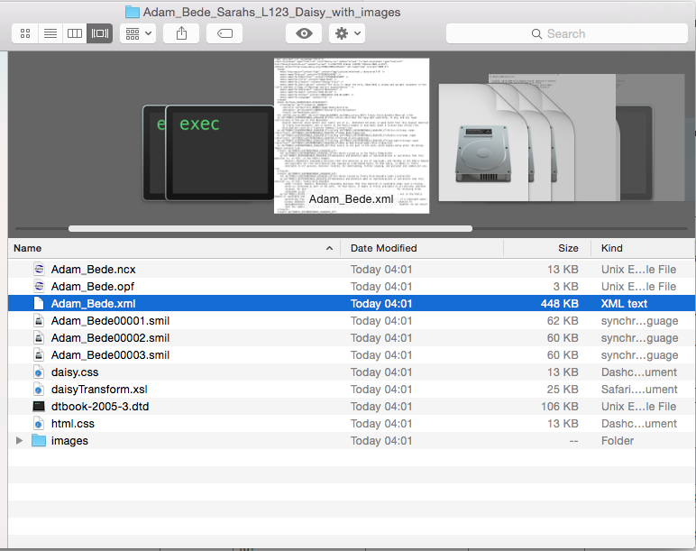

Rename the .xml file to end .html

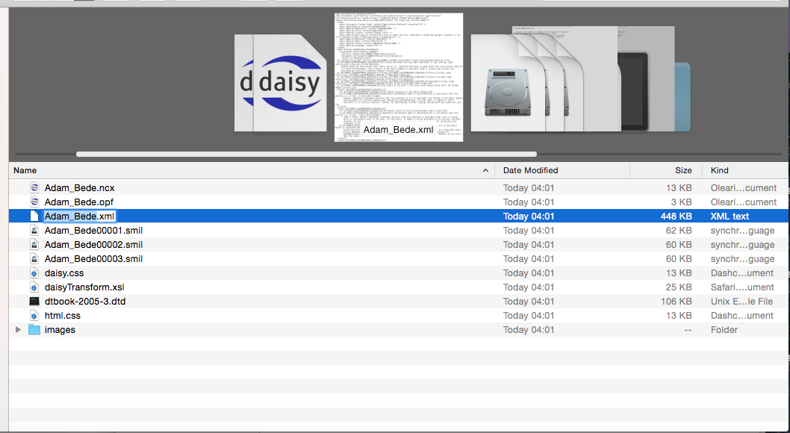

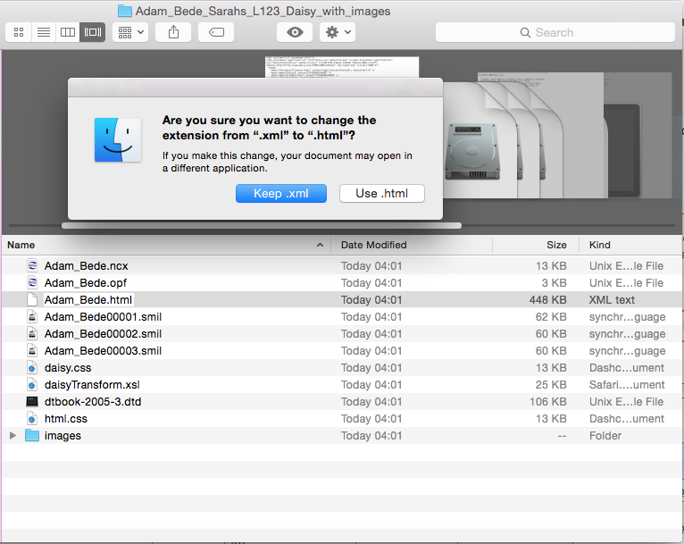

Now open the .html file in Safari

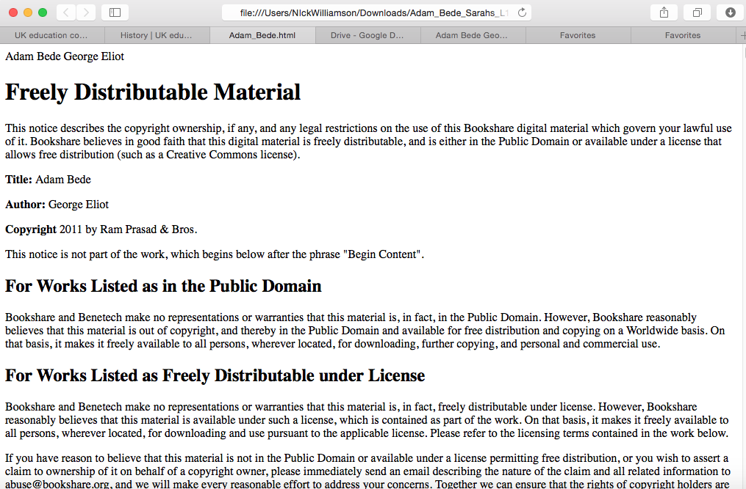

Select all and copy into a new Word document
Turn on your Document Outline to ensure the structure has been pulled through.

The book can now be modified to meet your learner’s requirements; font type, font size, line spacing, colours, etc.

---
Author: RNIB Bookshare
Date created: 30 January 2017
Last amended: 30 January 2017
Saved: M:\RNIB Bookshare\Guidance and training for customers\convert_daisy_to_word_mac.docx

