Creating Word documents from
RNIB Bookshare files

Supporting documents and systems 1
Quick guide 1
Full guide with screenshots 2

Supporting documents and systems

RNIB Bookshare | www.Load2Learn.org
RNIB Bookshare | Creating styled documents in Word 2010: a guide to making text more accessible
RNIB Bookshare | Guide to modifying structured Word documents

Quick guide

- Download the book in the “DAISY with images” format
- Open the zip folder and extract the files (Shift and F10, then T). The folder containing the extracted files will open automatically.
- Rename the “book_title.xml” file so that .xml becomes .html
- Double click on the .html file
- Select all of the text (Ctrl and A) and copy the text (Ctrl and C)
- Paste the text (Ctrl and P) into your blank Word document ensuring you keep the source formatting.
- The text and images are now in your Word document. You may need to resize images to fit the page.
- Turn on your navigation pane (ALT and W, then K) to display a menu of all the styled headings in the document, which give the document structure and make it quick and easy to jump to different sections of the text.
- The book can now be modified to meet your learner’s requirements; font type, font size, line spacing, colours, etc.

Full guide with screenshots

Search for the book you wish to download.

The quickest and easiest way to do this is to type the ISBN into the search field at the top of the site.

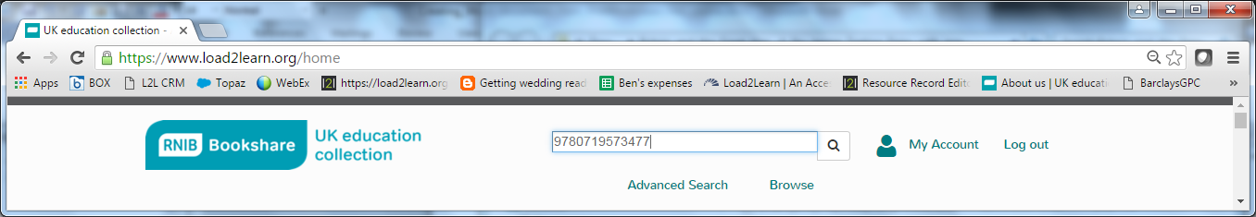

If the title appears in the search results twice, it is the entry that does NOT have (PDF) in the title that you want to download.

Select “Download”

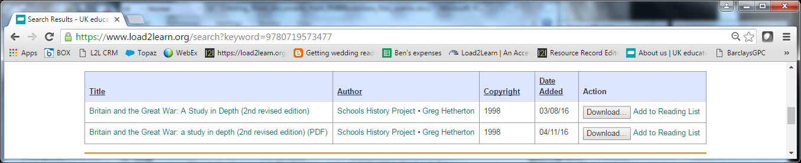

Check the box next to the learner you’re downloading the book for

Select the download format “DAISY with images”

Select “Download books”

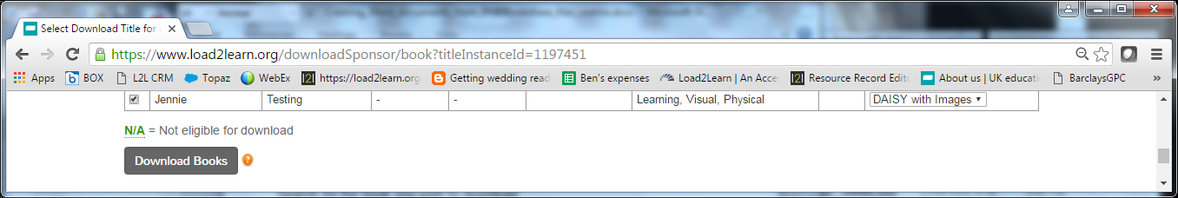

Confirm the “Download”

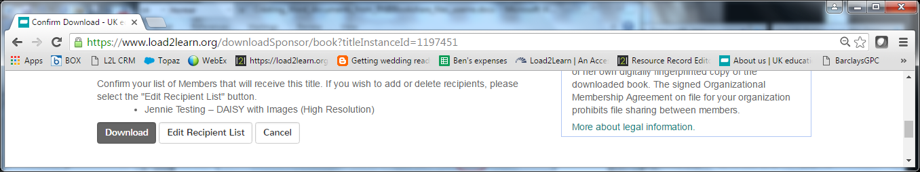

Once the download is complete, the status will change to “Available”

Select “Available” to download the zip folder containing the files.

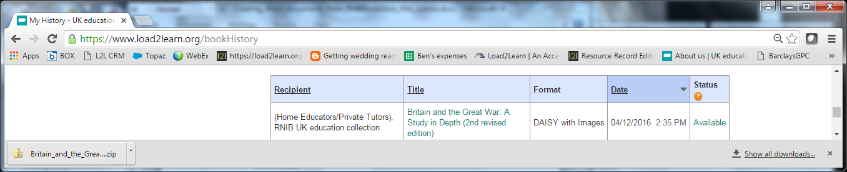

Navigate to the location where you saved the zip folder to (usually “Downloads” folder)

Right click on the zip and “extract all” (Shift and F10, then T)

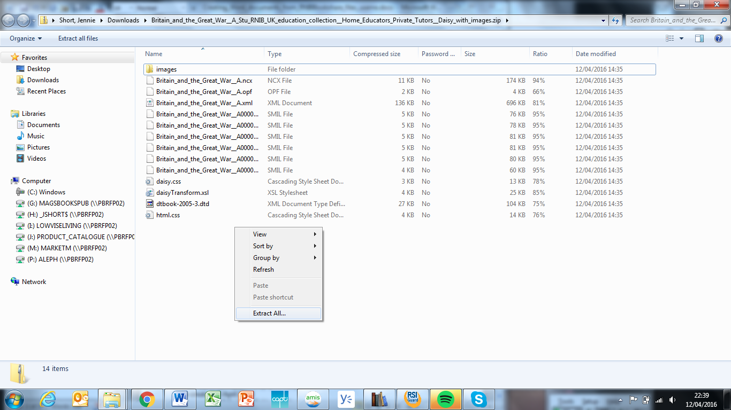

Choose where to save the extracted files and select “extract”

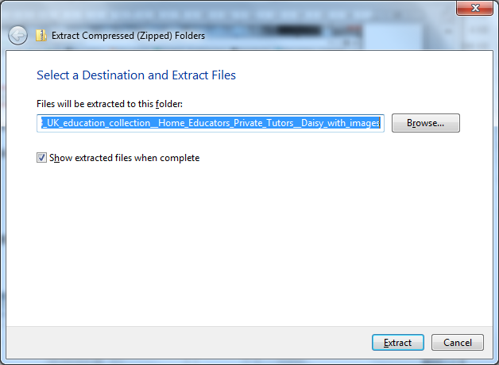

The folder containing the extracted files will open automatically.

Locate the “book_title.xml” file.

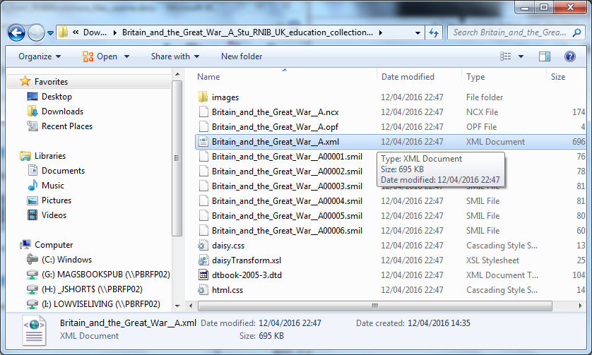

Rename the .xml file to end .html

This can be done three ways:

- Highlight the file name, and tap the mouse once more
- Right click / rename
- Shift and F10, then M

Now open the .html file

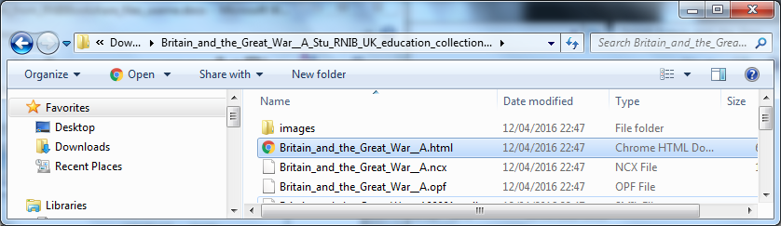

It will open in your web browser

Select all of the text (Ctrl and A)

Copy the text (Ctrl and C)

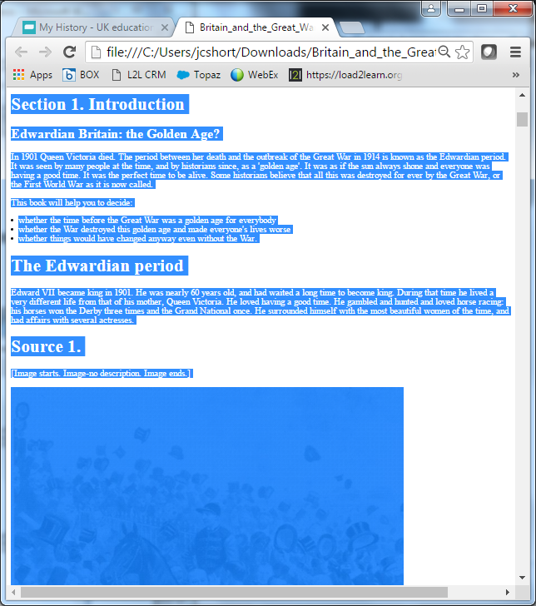

Open Word

Paste the text (Ctrl and P) into your blank Word document.

If your paste default is set to “keep text only” you will need to reset it to keep the formatting (ALT and H, then V, then A). Or you can right click and select the “keep source formatting” icon.

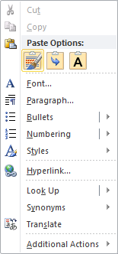

The text and images are now in your Word document. You may need to resize images to fit the page.

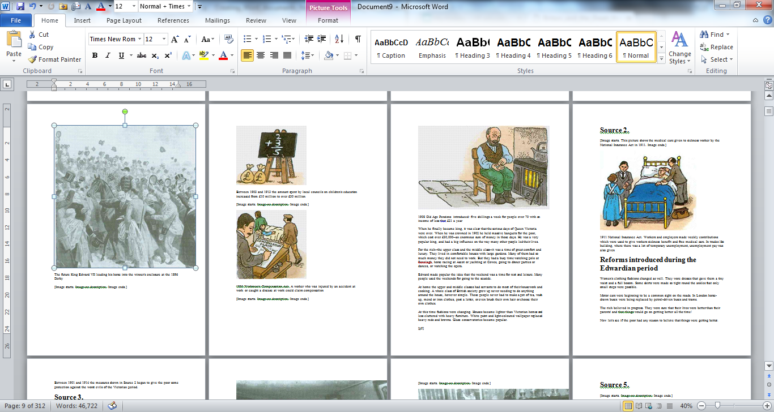

Turn on your navigation pane. This can be done two ways:

- Go to the View ribbon and check the “navigation pane” box
- ALT and W, then K

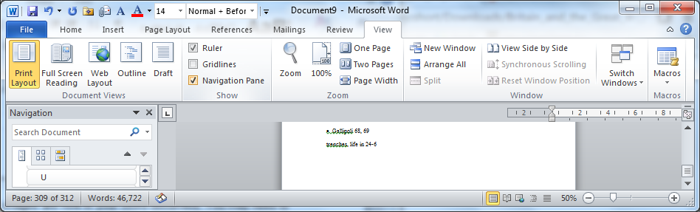

The navigation pane shows all of the headings in the book that have styles allocated to them and by selecting a heading in this pane, you can jump to that section of the book.

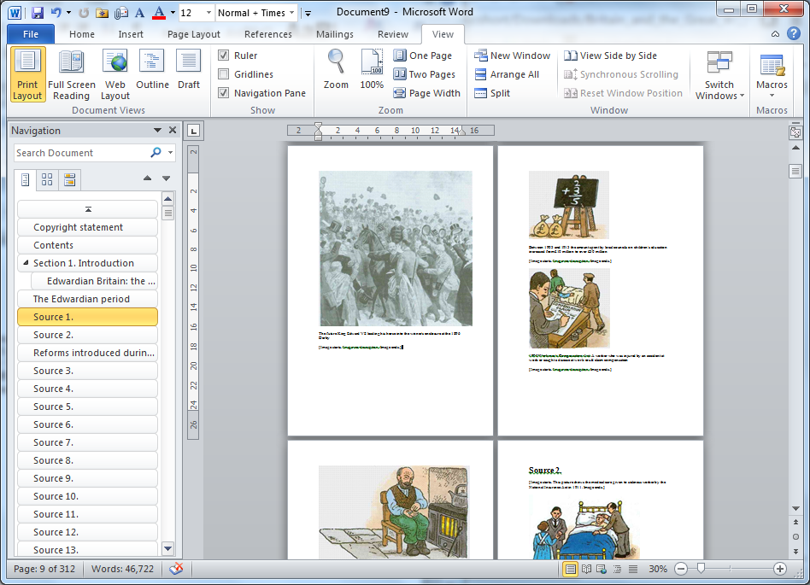

The book can now be modified to meet your learner’s requirements; font type, font size, line spacing, colours, etc.

---
Author: RNIB Bookshare
Date created: 12 April 2016
Last amended: 18 July 2016, Version 1
Saved: M:\RNIB Bookshare\Guidance and training for customers\Creating Word documents\Creating_Word_documents_from_RNIBBookshare_files.docx

