RNIB Bookshare Back to School News – September 2018

Welcome back!
We hope that you have had a fantastic summer break and are back refreshed. We have had a great summer, the biggest change has been in the number of titles we have, as we have reached over 120,000 titles! We are also excited about the range of content available to our print disabled learners. Read on and you will find out how we have so many!
Kind regards,
Stacy, Caroline, Ian and Teresa

Contents
New great reading content to discover 3
Praise a Publisher! 3
Book requesting 4
Forgotten your username and password? 4
Need to make any changes to staff and learners? 4
1. Changing your email address 4
2. Changing Primary Contact details 4
3. Adding/changing sponsor/staff details 4
4. Adding/changing learner/member details 4
Training films 5
Our Storyboard 5
Get in touch 5

New great reading content to discover
Our publishers have provided some wonderful leisure reading content on the site for your print disabled learners to access. Watch out for our fun reading pages that you can discover through our browse pages; as we provide ways for learners to find this fantastic content.

This can be a great, safe way for learners to learn to access new exciting content, outside of their reading lists, without feeling too overwhelmed. If you have any thoughts or ideas about how we can make this better for learners, please let us know.

Praise a Publisher!
Our publishers have been busy over the summer. We have several new publishers that are now working with us, that weren’t previously and others that are now providing titles and back catalogues by direct feed, which means we get more titles, much more quickly.
Here are some of our new publishers:
- Emerald Publishing – setting up a direct feed
- Chelsea Green – have joined us, with a direct feed
- Harvard University Press – have joined us, with a direct feed
- Hodder Education – now proving content through a direct feed.
- John Wiley and Sons – now a publisher accepting our book requests and providing titles via a direct feed.
- Packt – have joined us, with a direct feed

Penguin Random House is our biggest publisher news. They are one of (if not the) biggest publisher, and over the summer have joined RNIB Bookshare. They are sharing a huge amount of content via a direct feed. They have previously been unable to work with us, but their commitment to RNIB is immense and they have sent us their back catalogue! You should not need to request from them, please check the site as it should already be there!

Don’t forget that this will also apply to their many imprints (Puffin etc), so do check the publisher details to see if they are now sharing their titles with us.

Book requesting
We hope that you will find many more of the books you need already available on RNIB Bookshare.
If you need to request a title, please remember that this is our busiest time for requests, and plan to request any titles with as much notice as possible. Last year we processed around 1,400 requests!
It is also really helpful is you check ‘the publishers to contact directly’ and ‘publishers working with us’, as well as checking the availability of publisher files dates. This will help us to process book requests quickly and efficiently.
Finally, please make sure that you check the site for your title. As we have many publishers now that are adding their files directly to the site, you may find the title before we do! When we are advised by the publisher that it has been provided, we will let you know!

Forgotten your username and password?
Your username is your organisational email address that you provided. It will not have changed unless you have asked us to do so.
Your password has been set by you, hopefully you have made a note of it somewhere, if not you can reset your password.

Need to make any changes to staff and learners?
Here are some useful links for changes you need to make to your account details.

Changing your email address
How do I change the email address on my account?

Changing Primary Contact details
How do we change the Primary Contact on our account?

Adding/changing sponsor/staff details
How do I add staff to our account?

Adding/changing learner/member details
How can I add learners to our school /organisation account?

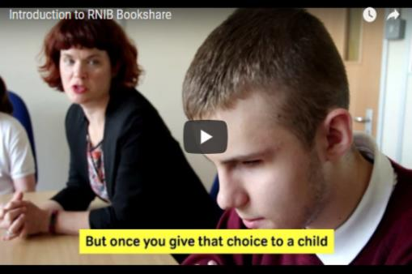
Training films
If you have forgotten how to do anything on RNIB Bookshare over the summer, don’t worry we have some brilliant films that show you how to do all the main tasks on the site. Discover our training films!

Our Storyboard
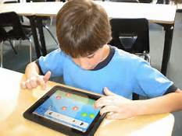
Storyboard is a new area on RNIB Bookshare. It’s where we are gathering your stories about using RNIB Bookshare whether you are a learner, parent, educator or publisher. We would love to hear from you, especially stories from and about learners.

These stories are so important to us in being able to keep RNIB Bookshare a free service in the UK to all from early learning literacy to further and higher education.

Get in touch

Please do get in touch if you need us. Again, please be aware that it is our busiest time, and so leave a message and we will get back to you!

End of document

