RNIB Bookshare – downloading resources from a staff (Primary Contact or Sponsor) account

Book formats available 1
Change your learner download preferences 2
Search for the book you need 2
PDF download 3
Downloading other formats 4
Web Reader tool – “Read now” 6
Reading lists 6

Book formats available
We may hold the file in two different formats, which provide a variety of download options.

PDF - the book record title will state PDF at the end of it and is only downloadable as a PDF.

EPUB - the book record title will not have anything at the end of it and it can be downloaded in the following formats:
- Daisy with images
- Daisy text only
- Audio (DAISY or MP3)
- Unified English Braille (Contracted or Uncontracted)

Change your learner download preferences
If you wish to change the download preferences for your learners (Members), so that a particular format always appears first in the download menu against their account, guidance on how to make these changes can be found in our Help Centre:
- https://www.load2learn.org/cms/help-center/change-download-format-preferences

Search for the book you need
The quickest way to find the book you need is to type the ISBN into the Search box at the top of any page on the site. Enter the ISBN without any spaces or hyphens.

- Log in
- Search for book

This example shows a title available that we hold both formats for and is presented in “table view”. You can switch between a table or list view depending on your preference. To change it select “list view”

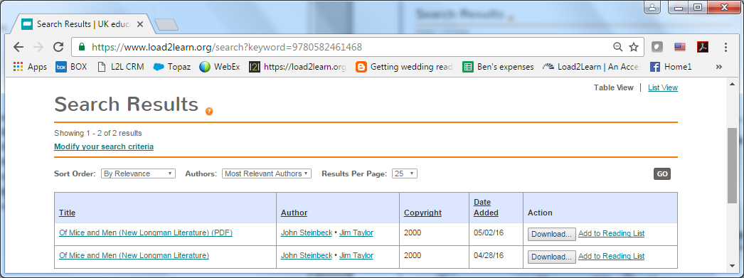

If you were logged into your learner’s Member account, you would also be presented with a “Read now” option for the file we hold as an EPUB.

PDF download
If you would like to download the PDF select “Download” next to the title with PDF in it.

You now need to select the learner your are downloading the book for by checking the box next to their name in the first column of the table. You can select more than one learner. This also makes the book appear in the “My history” section of the learner’s account, so they can easily access the file and use the “Read Now” option where it’s available.

- Select the learner(s)
- Select “download books”

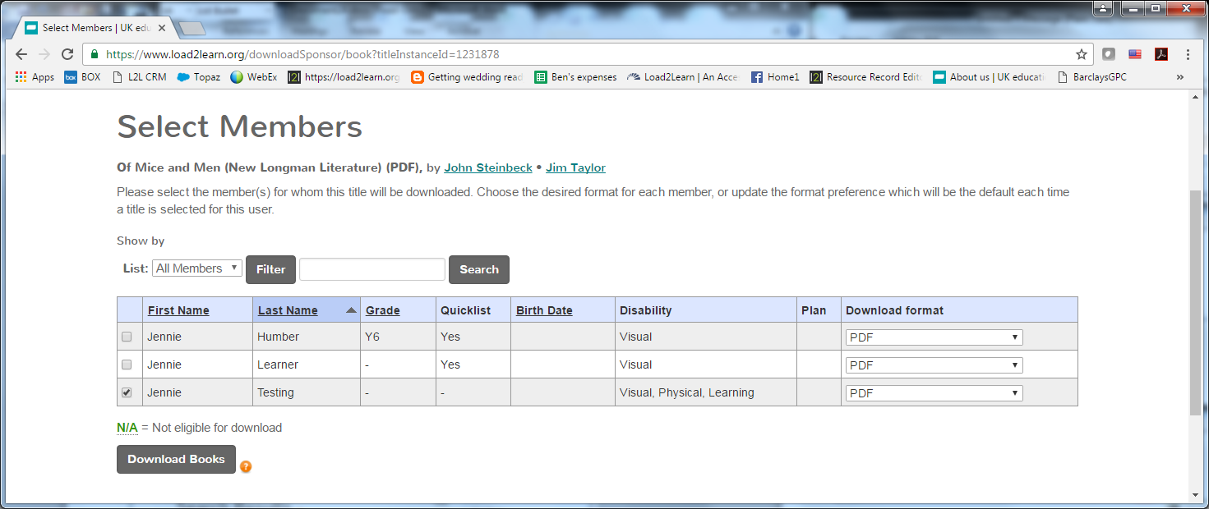

- Confirm your “download”

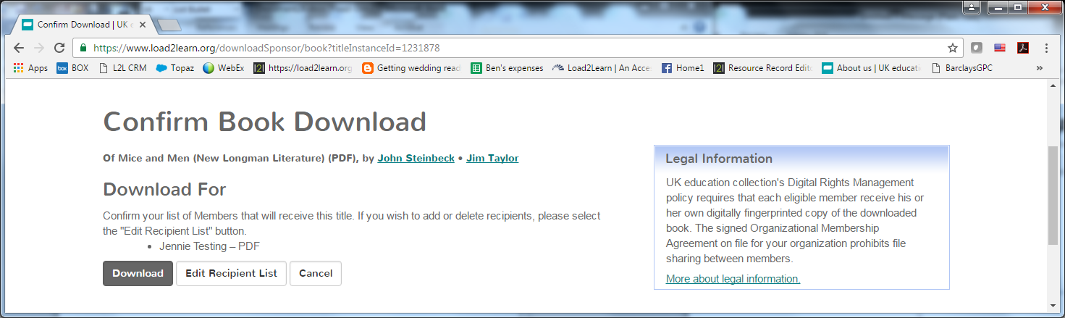

- You will be taken to your “My history” page where the book will be listed.
- Select “available” (note it may state “in progress” wait until it says “available”)

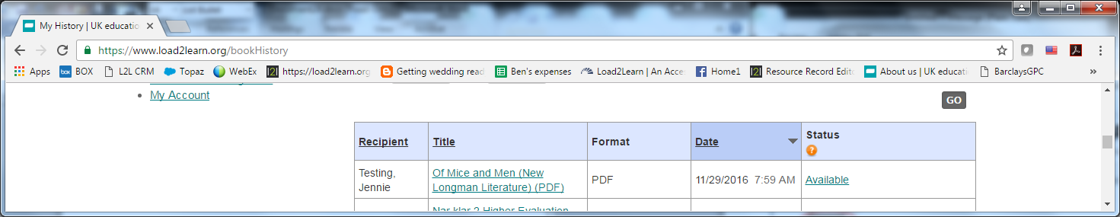

The PDF will download.
Depending on the browser you use and your computer set up:
- it may appear at the bottom of your browser window
- you can also find it in your browser download history
- or in your computers download folder

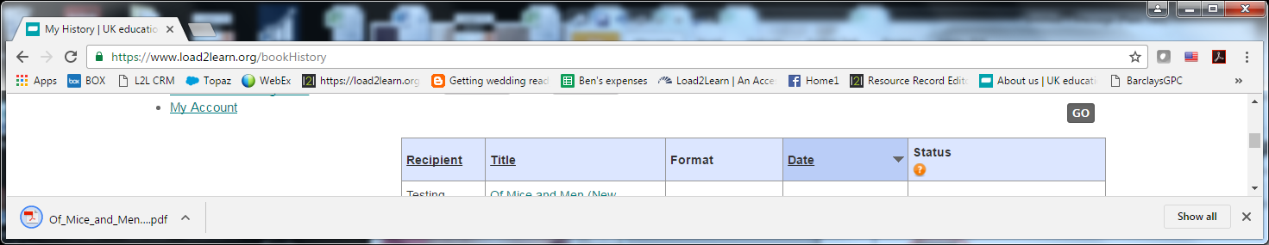

Downloading other formats
If we hold an EPUB file for the title it can also be download in these formats; DAISY, Audio and Braille Ready File (BRF).

- Select “download” next to the title that doesn’t have PDF by it.

Select the format you require from the “Download format” drop down menu.

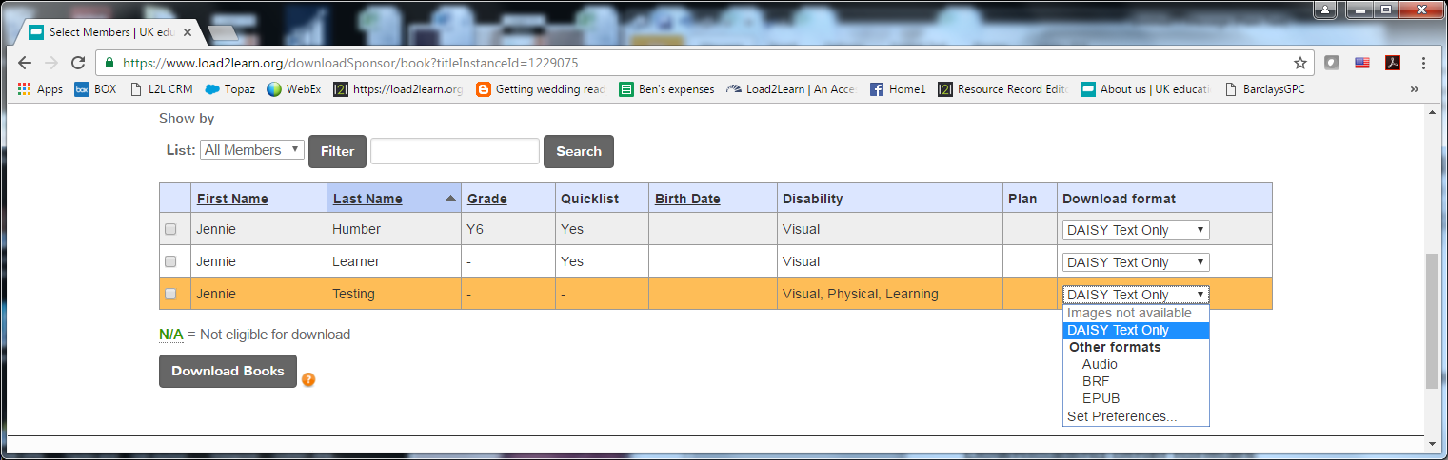

You now need to select the learner your are downloading the book for by checking the box next to their name in the first column of the table. You can select more than one learner. This also makes the book appear in the “My history” section of the learner’s account, so they can easily access the file and use the “Read Now” option where it’s available.

- Select the learner(s)
- Select “download books”

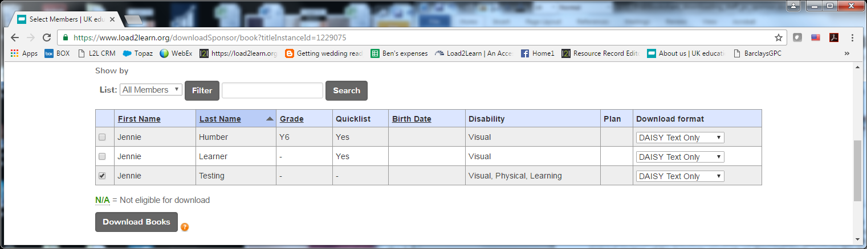

- Confirm your “download”

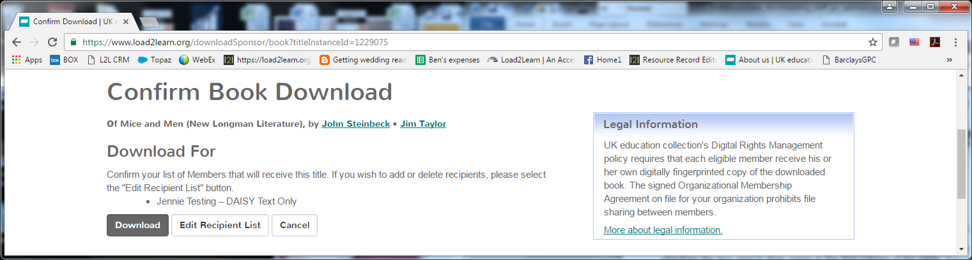

- You will be taken to your “My history” page where the book will be listed.
- Select “available” (note it may state “in progress” wait until it says “available”)

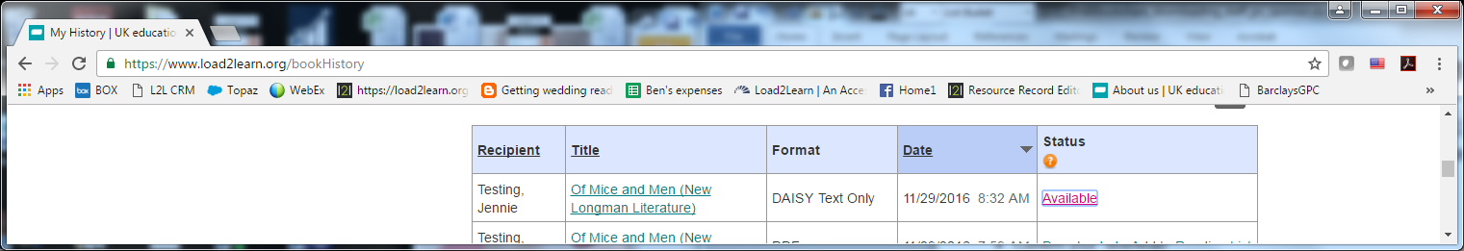

The file will download in your chosen format with a Zip folder.
Depending on the browser you use and your computer set up:
- it may appear at the bottom of your browser window
- you can also find it in your browser download history
- or in your computers download folder.

In order to access the files inside the Zip folder you will need to extract them:
- open the Zip folder
- right mouse click to bring up the menu options (you can also use the menu/application key or use “Shift F10” to bring up the menu)
- select “Extract all” from the menu or press “T” on your keyboard.

The menu/application key on your keyboard usually displays a rectangle with lines inside it and is often found next to the Windows key. For example:

Web Reader tool – “Read now”
Guidance on how to access the Web Reader tool can be found in our guidance for downloading from a learner (Member) account:
- https://www.load2learn.org/cms/help-center/downloading-learner

Reading lists
You can set up reading lists and share them with your learners (Members) and staff (Sponsors). If you find yourself needing the same books regularly, for example GCSE English Literature set texts, you can set up a reading list so you don't have to search for them each time they're needed. You can then assign the reading list to your learners so they can quickly access the books they need to read and you can also share your reading lists with other members of staff.

Guidance on creating reading lists can be found in our Help Centre
- https://www.load2learn.org/cms/help-center/create-reading-lists

---
Author: RNIB Bookshare
Date created: 29 November 2016
Last amended: 29 November 2016, Version 1
Saved: M:\RNIB Bookshare\Guidance and training for customers\ M:\RNIB Bookshare\Guidance and training for customers\Downloading general guidance\RNIBBookshare_downloading_staff_pc_sponsor.docx

